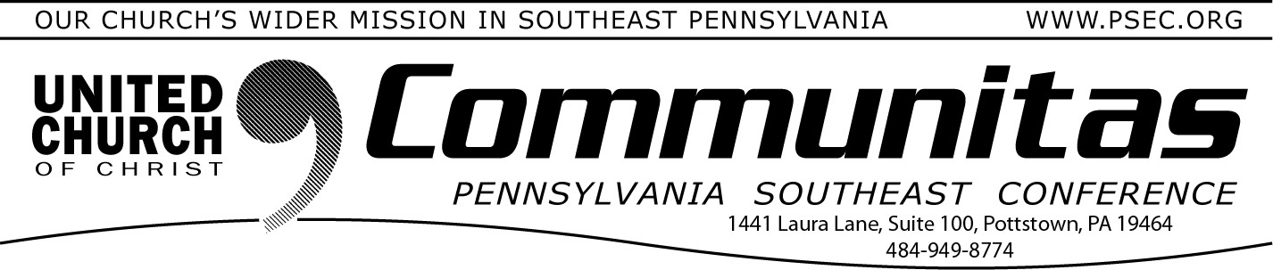
October 26, 2025

Reformation
300th Anniversary Celebrations of the First
Communion of the German Reformed Church in the United States October 15th, 1725—2025

- Sunday, October 12th @ Falkner Swamp UCC

Reformation Day (All Hallows Eve) is this Friday. Halloween has
completely over taken this day of remembrance in the culture and in many Protestant churches. Gone are the stories of giant people of faith, harrowing sacrifices, and dramatic confrontations that led to clarity of purpose and principles. However, we do still celebrate that the church is always being reformed, because it is made of human beings who, like the Pharisee in Jesus’ parable in Luke 18, are tempted to trust in themselves. He thanks God that he is not like other people—thieves, rogues,
adulterers. His prayer is more performance than petition.
But in the shadows of the temple stands a tax collector, who cannot even lift his eyes to heaven. “God, be merciful to me, a sinner,” he says, and Jesus tells us it is this man who goes home justified. Not because of his
eloquence. Not because of his theology. But because he knows his need of God.
Reformation Sunday still matters because it calls the church back to that
same humility. Martin Luther did not set out to start a new
denomination; he set out to tell the truth—that the church had lost sight of its dependence on God’s mercy. Five hundred years later, we still need to hear that truth. We are not justified by the strength of our traditions, our correct religious and political beliefs, or even our good works. We
are justified by grace.
The work of reformation is never finished, because God is always reforming us—turning us away from knowing we are always right and back toward mercy. Like the tax collector, all we can do is stand before God with empty hands, trusting that grace will fill them. That is reason enough to remember and give thanks.
- The Rev. Bill Worley, PSE Conference Minister

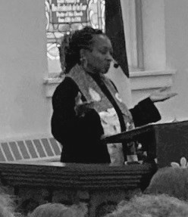
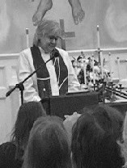
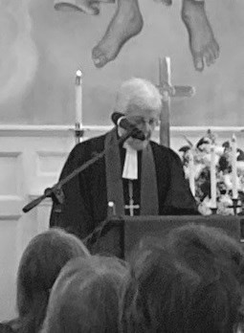
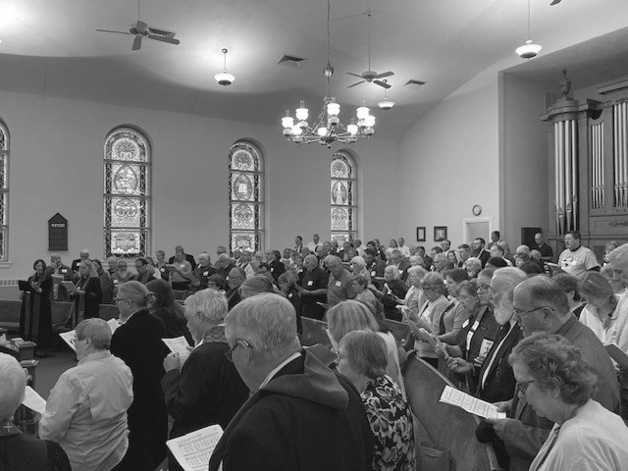
Wednesday, October 15th @ Wentz’s UCC
A few days before the actual anniversary date, the
sanctuary was full at Falkner Swamp UCC to honor our history and lift up the future. Our General
Minister and President, The Rev. Dr. Karen Georgia Thompson was present to deliver the message. There were many participants in the service including our Moderator, Rev. Melissa Burkhart and Rev. Dr.
Martha Kriebel.
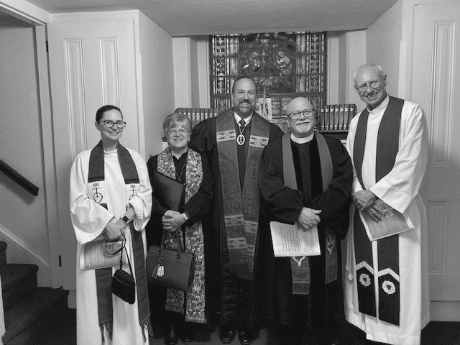
Just three days later, we shared communion on the actual communion date of October 15th at Wentz’s UCC. Special
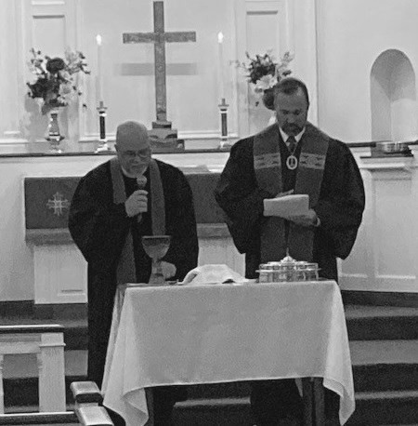
thanks to both churches for their planning and participation to make these events truly meaningful.

Clergy Participants: Revs. Amelie Castillo, Trudy Irving, Bill Worley,

Blessing
Communion
Kevin McLemore and Dave Heckler.

