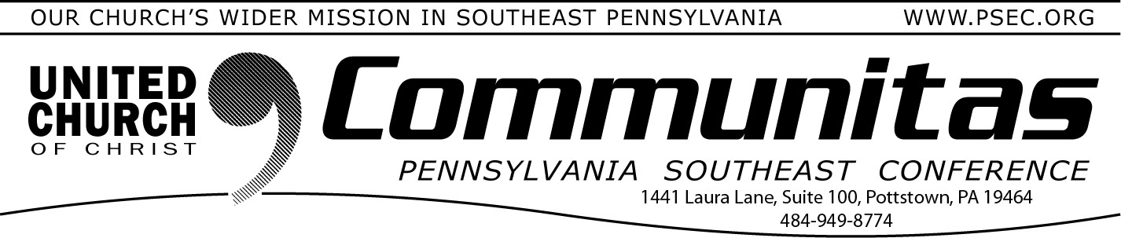
From the Conference Minister:
October 12, 2025
Register for Fall Meeting

300th Anniversary of the First Communion of the German Reformed Church in America

Today, in 1725, German refugees in the new Pennsylvania held their first
documented Communion service at Falkner Swamp Church in
Gilbertsville.
My ancestors, and I suspect some of yours, had left war-torn Germany with what they could carry. They traveled by the mercy and generosity of strangers in France then England where they were eventually sent packing in a fashion similar to what is happening now to refugees in
America. By the time they reached the ‘New World,’ they had less than that with which they left home. Somehow, they carved out an existence that has been passed down through the generations to us.
In that first Communion, I imagine German immigrants who longed for the stability of home, the resonance of their grandparent’s language, the assurance that God had not abandoned them in a new wilderness.
Communion gave them belonging – that they were not just scattered immigrants, but the body of Christ knit into a story stretching back to the first communion.
The people sitting in church have the same need. So do you. And me. It’s the need of all people created in the image of the divine—to belong, to be connected, and to be loved. That is the essence of our faith. Belong- ing. Connection. Love. Jesus built those things into a ritual we have to do (nearly) everyday to survive. Eating. Food for the body helps us live.
Food for the soul gives us a reason. Those two things taken together have helped humans survive one wilderness experience after another. Thanks be to God, they still do.
Rev. Bill Worley, Conference Minister
The final meeting of the Pennsylvania Southeast Conference of the United Church of Christ is more than a gathering; it is a sacred moment of remembrance and witness. It is the place where we honor decades of faithful ministry, celebrate the saints who gave their lives to the work of Christ in this region, and entrust the seeds of our future to God’s care. To attend is to take your place in the unfolding story of the Church —
bearing testimony to what has been, and offering your presence as a sign of hope for what is yet to come. Registration is open and prayers for your arrival ascend.
Blessings, R Pastor Bill

Final Meeting of the Pennsylvania Southeast Conference
Saturday, November 8 1:00-5:00p
St. Paul's UCC in Amityville Hybrid meeting

For free registration:
Go to psec.org, click the Events & News tab, click on the calendar, go to the November 8th date and click on the event
for more information.

As there will be no official business for this meeting, delegates are not required.


