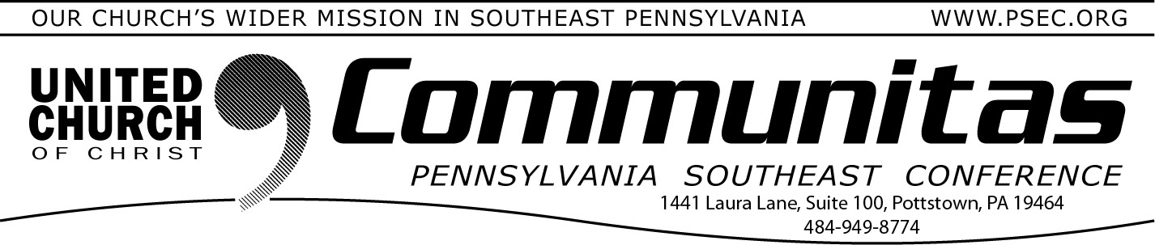
Protecting Places of Worship

September 28, 2025
Virtual Events from DHS

300th Anniversary Church Services of the First Communion
of the German Reformed Church in America
There are two separate worship services in October to lift up the
communion anniversary we have been celebrating since May.
Oct. 12th—3:00 service, reception following, at Falkner Swamp UCC
-in person and online—reservations REQUIRED—limited seating
A state-wide celebration on Sunday afternoon. The communion bread from this service will be shared out to all four conferences.

Oct. 15th—6:30 pm at Wentz’s UCC—in person and online, reservations required
A PSEC only celebration on the actual anniversary date.

For free registrations and information on all these events, visit the
300th Anniversary Celebrations page of our website for more
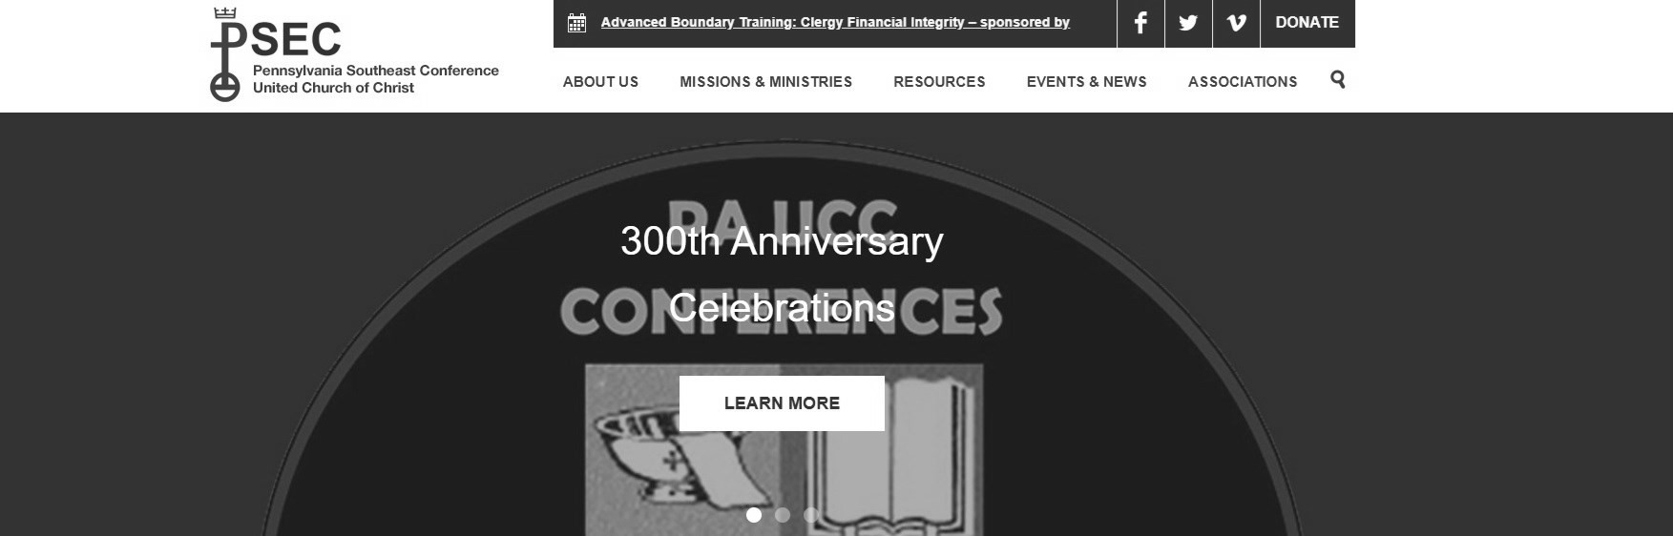
information. Do this by going to psec.org and clicking on the “Learn More” button on the 300th Anniversary Celebrations slider at the top of the home page.
In support of September's National Preparedness Month, the
Department of Homeland Security is coordinating "Protecting Places of Worship Weeks of Action." Online events include:
Active Shooter Preparedness
Introduction to Bomb Threat Management
Bomb Threat Assessment
Suspicious Activity Recognition for Bombing Prevention
Response to Suspicious Behaviors and Items for Bombing Prevention Introduction to Conflict Prevention Techniques
Conflict Prevention Strategies to Deter Targeted Violence Surveillance Detection Principles
House of Worship Active Shooter
For dates and to register, go to:
https://www.fema.gov/event/protecting-places-worship-weeks-action-
2025-calendar-events

From the Addiction & Recovery Taskforce: Healing Happens (1)

Recovery thrives in environments that say:
I see you. You matter. You’re not alone. A sense of security comes from having enough food, a roof overhead and support from people who care.

