

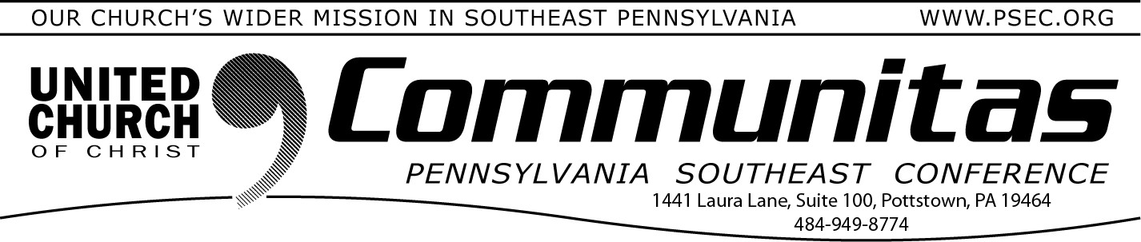

September 14, 2025

# Resources from the UCC

The UCC Daily Devotional is a spiritually deep well, to which thousands of readers are drawn each day. The

overall voice of the Daily Devotional is tended by the [Stillspeaking Writers’](https://www.ucc.org/stillspeaking-writers/)

[Group](https://www.ucc.org/stillspeaking-writers/) and supported by the staff of The

Pilgrim Press. If you are looking for a daily devotional or looking to perhaps add another, go to https://[www.ucc.org/daily-devotional/](http://www.ucc.org/daily-devotional/) to sign up.



Are you aware the UCC offers a one-click way to contact your

legislators on pressing issues? Go to the Justice & Peace Action Network at https://[www.ucc.org/action-center/](http://www.ucc.org/action-center/) .

The following topics are just a few of the many worthy causes you can support.

* Stand with Washington DC and Support D. C. Statehood
* Protect Trans, Nonbinary, and Intersex People’s Civil Rights
* Fight for Disability Housing Accommodations
* Blessed are the Peacemakers: Call for Nuclear Disarmament
* End US Military Support for Genocide in Gaza

1 Corinthians 15:58 NRSV - *Therefore, my beloved, be steadfast, immovable, always excelling in the work of the Lord, because you know that in the Lord your labor is not in vain.*

Frontline Faith is an online learning platform for the United Church of

Christ. They offer webinars, courses and events.

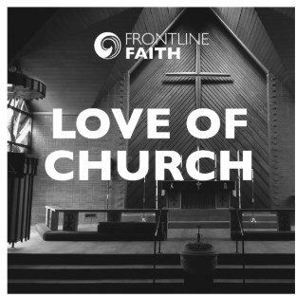These offerings are from the Faith INFO and MESA teams, Nurture the Soul, Racial Justice Ministries, Economic Justice Ministries, Environmental Justice Ministries and more.

These offerings are from the Gender and Sexuality Justice Ministries, Our Whole Lives, Global H.O.P.E., Global Ministries and our Office of Public Policy and

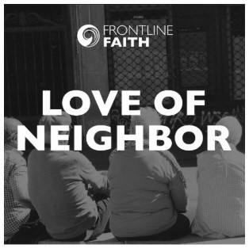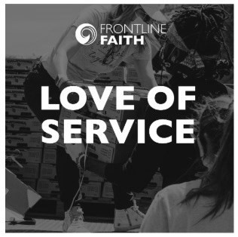

Advocacy in Washington D.C.

These are offerings are from the office of the General Minister and President, General Synod,

Human Resources and the Church Building and Loan Fund.

Access these resources at frontlinefaith.org .

# PSEC Fall Closing/Celebration Meeting

November 8th

@ St. Paul’s UCC, Amityville Douglassville PA