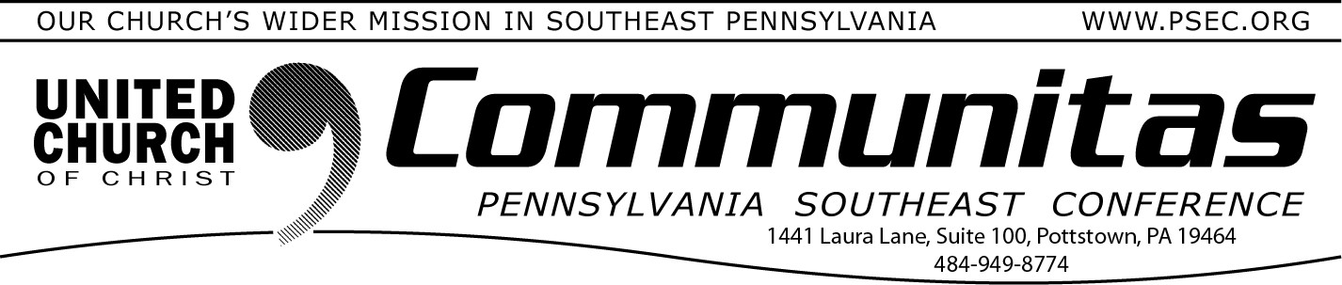September 7, 2025

# 300th Anniversary Celebrations of the First Communion in the German Reformed Church in America

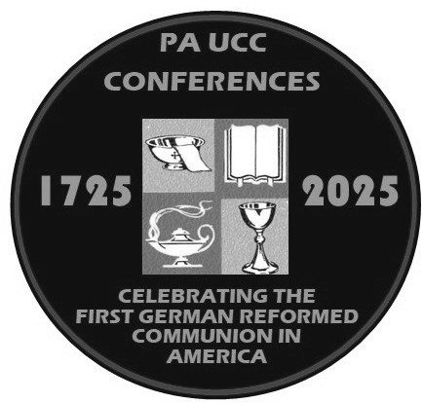Our celebrations of the 300th Anniversary of the first Communion in the German Reformed Church in the United States continue.

Two online presentations of German

Reformed History remain and are listed below.

September 25: *United and Uniting: How the UCC Makes Room for German Reformed and Armenian Evangelical Christians*

(Rev. Dr. Heather Ohaneson)

October 28: *A Lasting Legacy: Gifts of the Reformed Tradition to the emerging church* (Dr. Randall Zachman)

In addition we will hold two worship services in October to lift up the actual communion anniversary.

Oct. 12th—1:30 reception/3:00 service at Falkner Swamp UCC

-in person and online—reservations REQUIRED

A state-wide celebration on Sunday afternoon. The communion bread from this service will be shared out to all four conferences.

Oct. 15th—6:30 pm at Wentz’s UCC—in person and online

A PSEC only celebration on the actual anniversary date.

For free registrations and information on all these events, visit the [**300th**](https://yqw8o48ab.cc.rs6.net/tn.jsp?f=001d4G1L9Jjn8h4n-qeurEPx_8di_KvFNp3u-wk8qleH2EwSHp7QwA2jAQnYRRQlbULbT5qMHzbpFUTSoTc6ZEafDzcagmijC8s154D-K0wVWAXBHrdF54J5drYGW2ayR49y1l8XEhr7g_S5urcppO6mn9Rxz6lZy_IHLE4xs8LoN75NOGFaqcdONfqIpGIJSNxUOAySu8ofjqvZBl-cw1_rs4G7M)[**Anniversary Celebrations page**](https://yqw8o48ab.cc.rs6.net/tn.jsp?f=001d4G1L9Jjn8h4n-qeurEPx_8di_KvFNp3u-wk8qleH2EwSHp7QwA2jAQnYRRQlbULbT5qMHzbpFUTSoTc6ZEafDzcagmijC8s154D-K0wVWAXBHrdF54J5drYGW2ayR49y1l8XEhr7g_S5urcppO6mn9Rxz6lZy_IHLE4xs8LoN75NOGFaqcdONfqIpGIJSNxUOAySu8ofjqvZBl-cw1_rs4G7M)of our website for more information. Do this by going to psec.org and clicking on the 300th Anniversary Celebrations slider at the top of the home page.

# Falkner Swamp UCC

**Offering 300 Year Historic Tours on Sept. 20th**

**Celebrate 300 Years of Communion at Falkner Swamp UCC!**

Join us on **Saturday, September 20, 2025,** as we honor the **300th Anniversary of the First Communion of the German Reformed Church in the United States**, held right here at Falkner Swamp.

Come walk through history with a tour of our historic cemetery and building, stories of past pastors, unique artifacts, and a special presentation on Rev. John Philip Boehm, a founding leader of the

Pennsylvania German Reformed Church. And yes—there will be an **ice cream sundae bar**!

**Saturday, Sept. 20, 2025**

**1:00–4:00 p.m.**

**Falkner Swamp UCC, 2077 Swamp Pike, Gilbertsville**

All are welcome to this once-in-a generation celebration! For more information please contact Rev. Frances Chester, [pastorfalknerswamp@comcast.net](mailto:pastorfalknerswamp@comcast.net)

# Lay Leadership Support Group—Sept. 27th

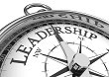A Lay Leadership Support Group exists that is ***OPEN to ALL Lay Leaders!***

***The group gathers the fourth Saturday of the month via Zoom from 10:00 – 11:00 am!***

They have found it to be a great place to form new friendships, to gain support, and to be educated on a variety of topics concerning our churches. The discussions are centered around sharing valuable

information about what our churches are doing or maybe could be

doing. This meeting will be online to make ease of attendance for all!

For more information go to psec.org, click on the Events & News tab and click the date on the calendar.