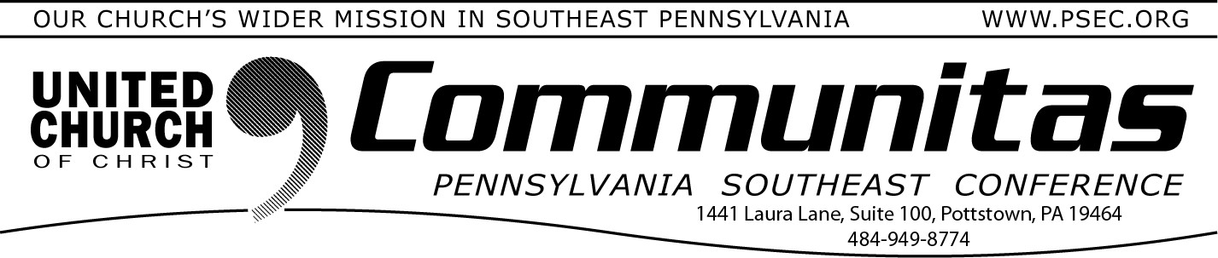August 31, 2025

# Four opportunities to review the 2026 Keystone Budget

**before the vote on November 22nd**

On November 22nd, the churches of the future Keystone Conference will have a zoom meeting to approve the Keystone 2026 budget. In order to familiarize yourself with that budget you may access it at by going to psec.org, and clicking on the slider at the top of the page

“Keystone Conference”, and scrolling down to “Keystone Budget”.

Members of the Keystone Budget & Finance team are offering four Town Hall opportunities, via zoom, to ask questions on the

budget, prior to November 22nd.

These sessions are a great opportunity to ask questions, gain clarity, and better understand the budget ahead of our online meeting on November 22, when we will vote on the budget’s approval.

There are four opportunities to participate: Sept. 8 – Monday 1:30 – 2:30 pm

Registration: [https://2026budget0908.eventbrite.com](https://2026budget0908.eventbrite.com/) Sept. 17 – Wednesday 10:00 – 11:00 am

Registration: [https://2026budget0917.eventbrite.com](https://2026budget0917.eventbrite.com/)

Sept. 22 – Monday 6:30 -7:30 pm

Registration: [https://2026budget0922.eventbrite.com](https://2026budget0922.eventbrite.com/)

Oct. 14 – Tuesday 6:30 – 7:30 pm

Registration: [https://2026budget1014.eventbrite.com](https://2026budget1014.eventbrite.com/)

# Still looking for volunteers for the 2026 Keystone Conference meeting

Plans are underway for the next statewide gathering of the Keystone Conference. The event will be held on Friday, June 5 through Sunday, June 7 in 2026. Our gathering will be held at

Millersville University in Lancaster County. This will be a time of worship, Being the Church, meeting new friends, and forming new relationships.

Several committees are forming to plan details for the 2026 event. If you are interested in serving on one of the following committees, please

forward your contact information (name, current Conference, and email address) to Shirley Keith Knox at [**skeithknox@comcast.net**.](mailto:skeithknox@comcast.net) All meetings are held ONLINE.

## Volunteers ARE Needed for the following Conference Planning Areas:

**Worship -** Volunteers needed in the following key areas: Visual arts – designing and preparing the worship and prayer spaces, music

leaders.

## Workshops - Assistance needed to identify and schedule workshop presenters.

**Display and Vendor Space -** Volunteers needed to identify and coordinate vendors and exhibits.

**Technology -** Volunteers needed to identify, operate, and obtain

technology for worship, hybrid business meetings, and workshops. **Mission/Service Project -** Volunteers needed to coordinate a Conference-wide mission project that occurs at this summer

gathering.

**Registration Volunteers -** Volunteers needed to prepare registration materials and assist at registration table at the university.

**Youth and Children -** Volunteers needed to identify childcare coverage

and youth programming.

**Fun & Hospitality -** Volunteers needed to coordinate a strong welcome upon arrival at the venue, as well as ideas for fun.

**Accessibility -** Volunteers needed to arrange signage and coordinate local arrangements for golf carts, scooters and other accommodations that

assure all attendees can fully participate in all events.