# From the Conference Minister:

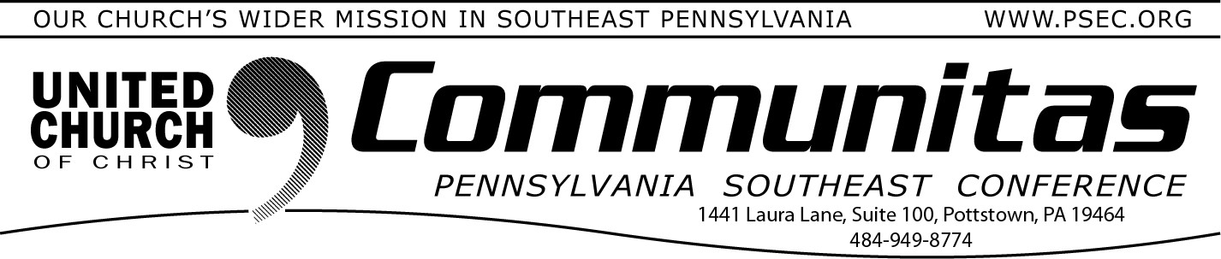

August 24, 2025

You are warmly invited to join a once-in-a-lifetime occasion—

## The 300th Anniversary of the First Communion of the German Reformed Church

Sunday, October 12, 2025, at 3:00 p.m. Falkner Swamp United Church of Christ

While the service will be live streamed, the sanctuary only seats 200 people. The meeting is hybrid so we need you to register regardless on how you plan to attend. You will not be able to attend in person, if you have not registered to do so. Register by going to psec.org and click on the 300th anniversary slider. Then scroll down to the Oct. 12th event and click the register button.

Our celebration worship will honor this remarkable legacy with inspiring music, reflections by our UCC General Minister and President, the Rev. Dr. Karen Georgia Thompson, and the sharing of the Lord’s Supper in the same spirit of

gratitude and faith as our ancestors. We will give thanks for God’s steadfast love over these 300 years and look forward to the new chapters yet to be written.

Be part of this historic moment as we remember the past, rejoice in the present, and renew our hope for the future.

# From the Addiction & Recovery Taskforce: Substance Abuse and the Big Beautiful Bill

## One Big Beautiful Bill: Churches, what can YOU do to support people with Substance Use Disorder (SUD)?

Learn about Substance Use Disorder & how it affects the brain

Get educated!

## [What is Substance Use Disorder? | SAMHSA](https://yqw8o48ab.cc.rs6.net/tn.jsp?f=0011dUayIM6D7pWUl5K06nSqw_FHBNvnjVdJaCa72pzJkb3LTRomIO92ylvtP3EzzTESvuUQmqDCvgkIRz55HO8d3MD02cwGz27EU-iiBaPetLSouXBTywAC_6TwcIxsIe41-OwPDHci87d23l_2x_MAjpXaEsaw-Z5GzsHBxsD4--n-C8T999f2z3vkkE9nZfB&c=wZ-7DNstck__4vyJJxQ2R9R)

Medications/Sermons involving SUD

People suffering from SUD and their families attend church too!

Jesus called us to love – One way to share that love is by presenting a meditation/sermon on how your church is called to care for people with SUD & their families. Imagine how people will feel knowing they no longer need to hide their truths.

Offering prayers for those suffering with addiction

Call for your Pastors & leaders to have specific, open prayers for those

affected and their loved ones. You do not need to use names but perhaps offer an altar call so people can be surrounded by others that care. God works through us!

Do this regularly – Make it a special service and put the word out to the public!

Meeting spaces

Decide if your church would offer safe space for meetings to a 12-Step or other recovery focused program.

Think Narcotics Anonymous (na.org) & Alcoholics Anonymous (aa.org)

When contacting them, ask to be connected with your local area Public Information Committee and request a PI presentation to get you started.

Holding workshops

Reach out to the PSEC Addiction & Recovery Task Force to find ways to hold helpful workshops or get help creating your own.

Volunteering support (temporary housing, food donation, etc.)

Remember that suffering happens to people year-round, not just a few days a year.

Consider your churches resources and willingness by involving everyone in open discussions about where God is calling your church to be of service.

Create a plan accordingly – Can you… offer a temporary safe space for some- one? have food gift cards and groceries on hand to give out as needed? provide some home-cooked meals to a distressed family? offer a home visit, just to simply listen or share a prayer?

During these times of uncertainty where things feel overwhelming and divisive, doesn’t it feel good to know we have God to hold us and walk next us? Who are we to keep Him all to ourselves?