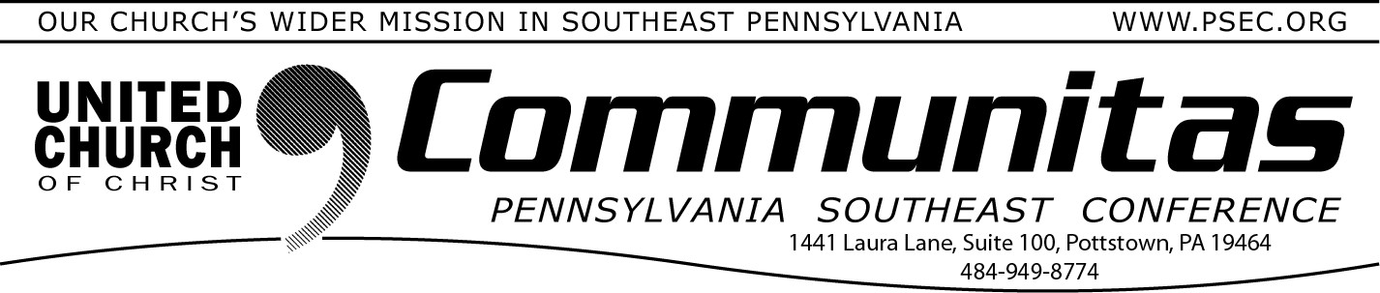chose the new Keystone Logo (from 4 finalists submitted by members across the Conferences – to be revealed soon), and chose dates for upcoming monthly Board meetings.

August 17, 2025

***“Like good stewards of the manifold grace of God, serve one another with whatever gift each of you has received.”* (1 Peter 4:10)**

Dear PSEC Friends,

With the help of Rev. Dr. Carrie Call who drafted much of the information

that follows, I have VERY important and history-making news to share.

This past Friday something momentous occurred: the first meeting of the Board of Directors of the Keystone Conference of the UCC. This all-day

meeting took place at St. Thomas Church in Linglestown and accomplished a wide variety of mission-critical tasks.

The 16-member Board spent time in fellowship and prayer, shared stories, and got to know one another. Following lunch the official board meeting began. The new Board worked well together immediately. First on the

agenda, the election officers. The positions of Chair, Vice-chair, Treasurer and Secretary were filled by a member of each current Conference. They are Dave DeRemer (Chair, PNEC); DiAnn Baxley (Vice-chair, PCC); Deborah Long (Treasurer, PW), and Bob Ames (Secretary, PSEC).

The Board approved staff job descriptions and named most of our

Conferences' current administrative staff to their positions: Sue Creswell (Executive Admin), Brea Rarick (Admin Region 1 Assistant & data-keeper),

Paul Keller (Admin Region 2 Assistant & Social Media Coordinator), Andrea Kopak (Part-Time Administrator for Region 3). The Board also elected Rev. Dr. Carrie Call to serve as the Transitional Executive Conference Minister (TECM) alongside Rev. Kevin McLemore (Region 1), Rev. Dr. Nora Foust

(Region 2), and Rev. David Ackerman (Region 3) as Transitional Regional Conference Ministers (RCMs). The remaining 2 part-time leadership

positions and the Bookkeeper will be named by September.

The Board voted on the location of the Keystone office (Harrisburg), discussed lingering Constitution and Bylaws questions, chose a temporary Nominating Committee to create a slate for the 11/22 state-wide business meeting, adopted an investment policy, reviewed and accepted the Budget for 2026 (to be voted on by all Conference members via Zoom on 11/22),

They also began planning a Board weekend retreat for January. Finally, they reviewed a list of remaining financial, governance, and mission tasks that must be completed before January 1. The next Board meeting is

September 8.

This work has been years in the making. The generally smooth yet some- times lurching process demanded much of the Keystone Working Group

and the four Conference Ministers. It also demanded tenacious faith in the reality of God’s activity in our lives and the movement of the Holy Spirit in our work. Thank you, good people of Pennsylvania Southeast, for walking this journey. Thank you for showing up at Town Hall meetings, asking

questions, sending emails, reading updates, praying, challenging assumptions, and ultimately, for voting to make this real.

Mark your calendars for the first Keystone Conference meeting **June 5-7,**

**2026** at Millersville University and for our PSEC Farewell Celebration Service on **Saturday, November 8** (at St. Paul’s, Douglasville) for a time of

remembrance, celebration, and thanksgiving for the 60+ years of amazingly faithful Conference ministry.

With the Peace of Christ,

Bill

- Rev. William P. Worley, PSE Conference Minister

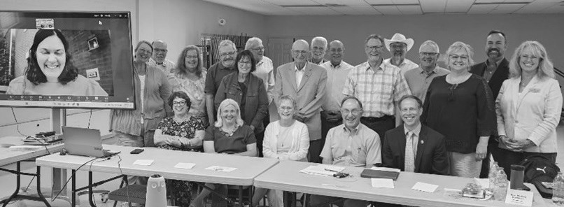The Keystone Board of Directors