**Volunteer Work Groups Needed**



August 3 2025

**for Western North Carolina**

**Handbooks from Resources UCC**

# Handbook for Visitation: Children and Youth

Visiting youth with family members present

differs from visiting adults. Meeting the needs of these distinct age groups simultaneously can be challenging. Some visits will occur in a

hospital, others will take place in pediatric rehabilitation, and many more will happen in family homes.

Pediatric chaplains and faith formation leaders are the primary contributors to this handbook, offering key resources to meet the needs of this special group.

# Handbook for Visitation

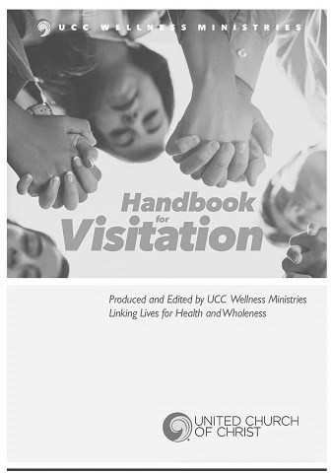The Handbook for Visitation from UCC Wellness Ministries is designed to support those doing

visitation, whether experienced or new to this ministry. The role of connecting with people on

behalf of a church is not just a responsibility but a significant part of ministry. The *Handbook* will

guide and empower you.

As church representatives, we are entrusted to share God's love and comfort with those in need while honoring their life experiences and

perspectives. The handbook includes quotes from scripture, prayers, and blessings covering many situations, thus serving as a handy

reference for those unexpected occurrences.

**Both resources may be purchased at uccresources.com.**

We have all seen the pictures and heard the stories of the devastation that Hurricane Helene ravaged on North Carolina almost a year ago.

**Now volunteer work groups are requested to help rebuild in Western North Carolina.** [High Country United Church of Christ,](https://highcountryucc.org/about-us) 8233 Highway 421-N, Vilas, NC 28692, has launched their volunteer host

site: [Volunteer Housing | High Country United Church of Christ.](https://highcountryucc.org/housing) They are accepting groups of up to 20 people. Volunteers will be staying at the church for $60/person/week, and the church is coordinating work in the area with a variety of different community organizations to do rebuilding and recovery work based on the skills/interest of the volunteers.

They will be accepting volunteers for about 6 weeks from mid- September to early November this year and then will reopen in early spring 2026.

You can see pictures of the facilities and learn more go to:

**https://highcountryucc.org/housing**. If you have questions, send us an

email to [**admin@highcountryucc.org.**](mailto:admin@highcountryucc.org)

**From the Addiction & Recovery Taskforce:**

**Quote**

“The true measure of a person is not where they stand in times of

comfort, but rather where they stand during challenges and

controversies.” – Dr. Martin Luther King Jr.