Your generous donation to UCC Global HOPE’s Disaster Ministries,

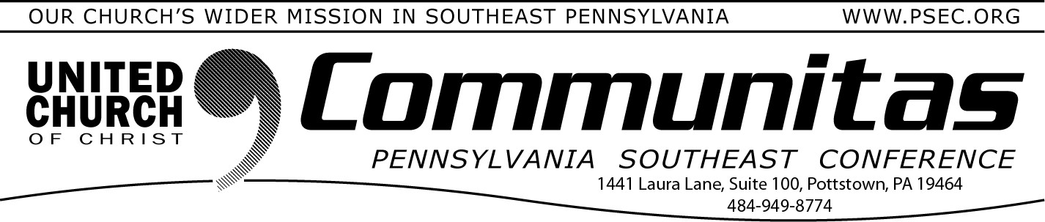

July 27, 2025

specifically reserved for this event, helps our church continue to serve! Donations can be made through the Pennsylvania Southeast Conference, indicating "Severe Storms" on your remittal form.

# Raising Alarm About a Consolidation of Power, General Synod Delegates Reject Bylaw Change

With speakers raising the alarm about a consolidation of power, voters at the 35th General Synod rejected a [proposed revision to the UCC](https://www.ucc.org/changes-to-uccs-constitution-and-bylaws-to-be-considered-by-general-synod-35/#%3A~%3Atext%3DThe%2035th%20General%20Synod%20of%20the%20United%20Church%2Cproposed%20amendments%20to%20the%20UCC%20Constitution%20and%20Bylaws)

[Constitution and Bylaws](https://www.ucc.org/changes-to-uccs-constitution-and-bylaws-to-be-considered-by-general-synod-35/#%3A~%3Atext%3DThe%2035th%20General%20Synod%20of%20the%20United%20Church%2Cproposed%20amendments%20to%20the%20UCC%20Constitution%20and%20Bylaws) which would have changed the Associate General Minister positions from being elected by Synod to being appointed by the General Minister and President.

The proposal lost by a vote of 407 against and 241 in favor, with 34 abstentions. The revisions needed to be approved by two-thirds of Synod voters, followed by ratification by two-thirds of the Conferences. Delegates debated the change for 45 minutes, with several speakers pointing to the current Trump administration as an example of the

dangers of putting too much power into one person’s hands. Many said that while they trust the current General Minister and President/CEO, the Rev.

Karen Georgia Thompson, they wanted to protect against future abuses of authority.

# Help is needed in Central Texas

Earlier this month heavy rainfall and catastrophic flash flooding devastated areas of Texas. More than 100 people were killed or remain missing,

including dozens of children. The flooding displaced many people,

destroying homes and severely damaging critical infrastructure, including roads and river crossings.

When a humanitarian crisis of this magnitude strikes, United Church of Christ Disaster Ministries is ready to help. The Disaster Ministry Team at the National Ministry of the United Church of Christ has been in contact with the Conference Disaster Response Coordinator and the Conference Minister for the South Central Conference to monitor the situation and determine how best to support communities. **We need your help to**

**empower our churches and members in the impacted areas to help their communities recover. Your donations can make a difference.**

# Vote at General Synod for the formation of the new Keystone Conference—Passes Overwhelmingly !

Dear Keystone Friends,

With full hearts and joy filled spirits, we are thrilled to announce the historic passage of the motion to create the Keystone Conference of the United Church of Christ! **By a vote of 98%** (640 in favor, 8 opposed, 6 abstentions), delegates of the 35th General Synod approved the

realignment of our Conference boundaries. This moment marks the culmination of several years of faithful discernment, courageous conversation, and a shared vision for the future of our ministry in

Pennsylvania. Together, we have dared to believe that God is still speaking

— and calling us into something new.

The creation of the Keystone Conference is more than a structural shift; it is a bold witness to our commitment to covenant, collaboration, and the continuing call of the Holy Spirit. We honor the legacy of those who have gone before us in each of our four Conferences and rejoice in the new pathways and possibilities now open to us. We give thanks for the Keystone Working Group, Conference staffs, and all who labored, prayed, and dreamed this into being. And we move forward with gratitude, humility, and a renewed passion for the Gospel.

We trust that the One who began a good work among us will be faithful to complete it.

In faith and hope,

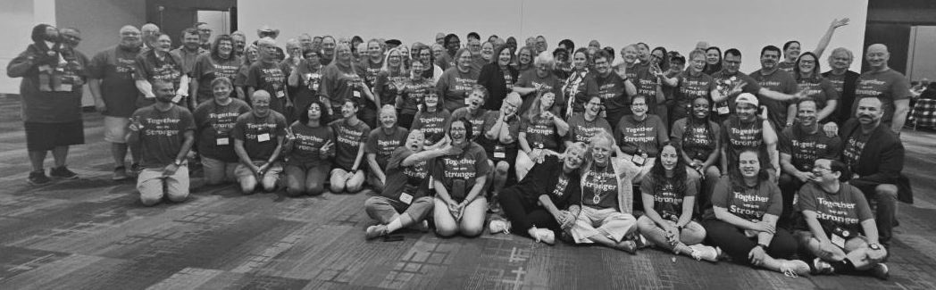Bill, Bonnie, Carrie and David (CMs of the four PA UCC Conferences) Synod delegates of all four PA Conferences in their Keystone shirts!