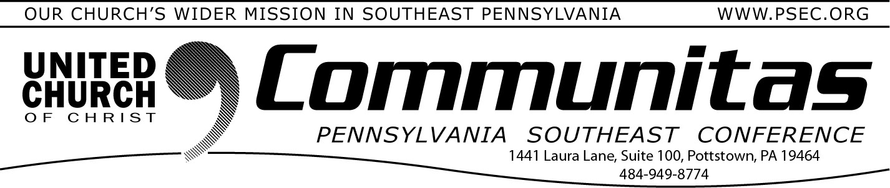June 15, 2025

# Recap of Last PSEC Annual Spring Meeting

Saturday, May 31st was the final Spring Meeting of the Pennsylvania Southeast Conference. Highlights of the meeting included worship,

being together, approving the Keystone Conference Constitution and By-laws and the Keystone Transitional Board Members, and the Anniversary Celebrations. We lifted up anniversary churches

celebrating 25 year anniversaries and Pastors celebrating anniversaries of their Ordination year.

If you missed the advance reports for the meeting, those are still

available on the PSEC website by going to psec.org clicking on the tab

“Events & News”, clicking on the subtab “Conference Events” then

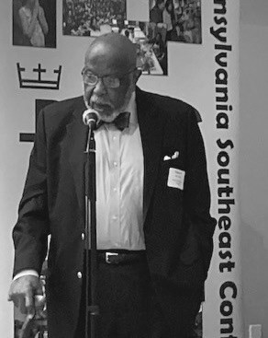

**Rev. Robert L. Polk—70 years**

# Anniversary Pastors 55+ yrs.

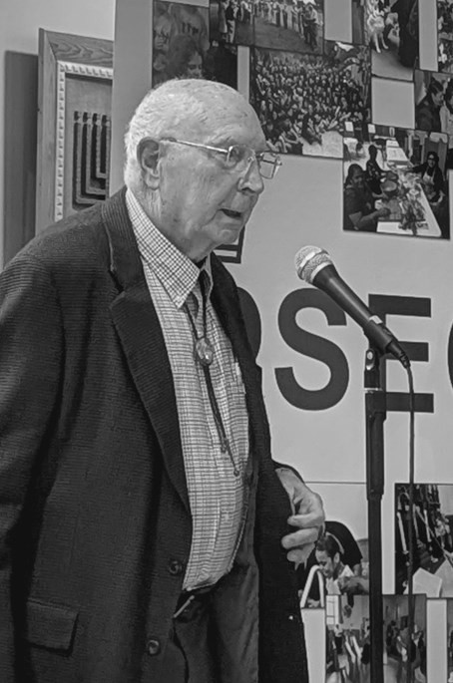

**Rev. Arden C. Hander—65 years**

clicking on the subtab “Annual Meeting 2025”.

During the meeting Conference Moderator, Rev. Melissa Burkhart gave a updated report on the Keystone Conference. The report can be found by going to psec.org, clicking on the Keystone Conference slider and then scrolling down to resources on the Keystone Conference page.

Melissa’s report is the first item under “Resources”.

When celebrating Anniversaries, we lift up every pastor who during 2025 is celebrating a 5th, 10th, ….70th year anniversary of their

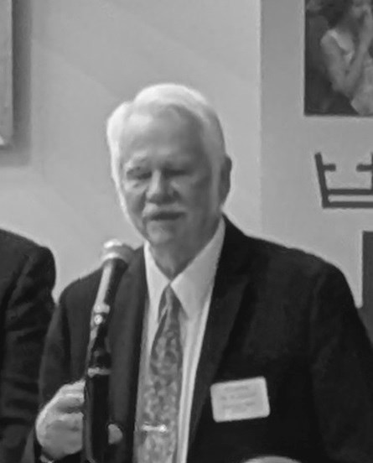Ordination date. This is a special time especially when we are honored to have so many pastors with us who were celebrating more than 50

years of Ordained ministry. I dedicate the remainder of this Communitas to those special individuals. These individuals were presented a plaque and received our sincere thanks for their dedication. We were blessed to hear from each of them.

50+ Year Anniversary pastors unable to attend:

Rev. Herbert R. Davis and Rev. Dr. Elizabeth W. Fenske—65 years Rev. George H. Schmidt, Jr.—60 years

Rev. Mark D. Dewald and Rev. Daniel T. Moser, II—50 years

**Rev. Dr. Paul R. Hetrick—65 years**

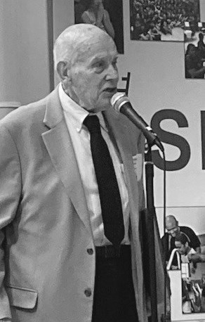

**Rev. Howard L. Kriebel—65 years**

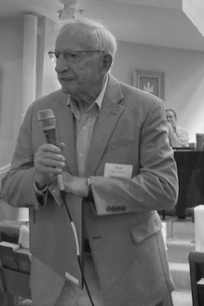**Rev. Dr. Charles A. Maxfield—55 years**