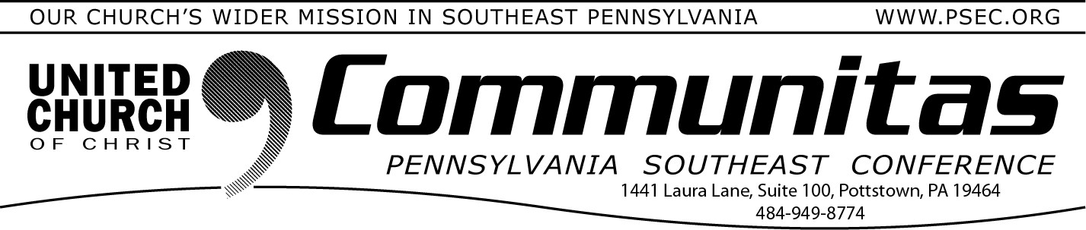June 8, 2025

# How to Support Disaster Ministries Following Catastrophic Storms

Catastrophic storms and tornadoes have ravaged communities across the South and Midwest United States, claiming dozens of lives, displacing countless families and leaving tens of thousands without power. In St.

Louis at least 2 UCC churches were damaged.

When a disaster of this magnitude strikes, United Church of Christ

Disaster Ministries is ready to help. Our Conference Disaster Response Coordinators help to guide our work and the funds that our members donate. Our grant program, our network of coordinators, and our

Emotional and Spiritual Care Team empower people and churches in the impacted areas to help their communities recover.

**Your donation makes a difference.** To support the relief and long-term recovery of those affected by these severe storms, and other communities that have experienced similar events across the US, go to: https://support.ucc.org/global-HOPE

To learn more about UCC Disaster Ministries, go to: [ucc.org/disaster.](https://yqw8o48ab.cc.rs6.net/tn.jsp?f=001TWXsCcI0TRiswFsTE9K-8Q7wPMZpZQ36iSGV8hmueTiNfY4lpLjdO9Qort3CraX_1QGDLO20ISY7_o1UV73qRMcGcG7hOZMsczUMpPcJrdhWpp75NlJY8a0P-oC3t-ZRex8Ja8xXeLNWTz-r8Ol7fvBECmwRA6_e&c=2w999sxooPL2OemI-PXIp4nc8bGZpTH1jgrGsVJ4SyJW5C2uPxa7Tw%3D)

# Check next week’s Communitas for….

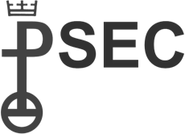...a re-cap of the 2025 PSEC Spring Meeting which took place on Saturday, May 31st!

# 300th Anniversary Celebrations of the First Communion in the German Reformed Church in America

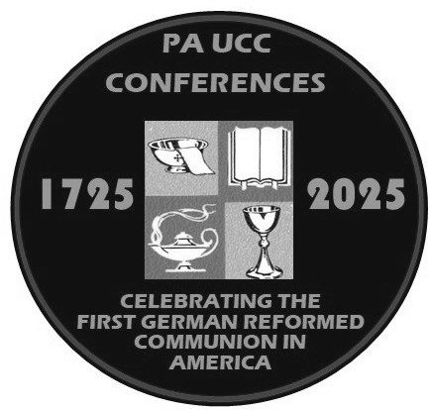This year we will celebrate the 300th Anniversary of the first Communion in the German Reformed Church in the United States. This began with the first communion at Falkner Swamp, Oct. 15,

1725. This celebration of our immigrant heritage is particularly meaningful and instructive given

the current conversations about immigration

happening around the nation.

To celebrate, a series of events and worship celebrations are planned, including (among other things) quarterly presentations of German

Reformed History, a liturgy for congregations to share on the morning of Sunday, Oct. 12 and a Festival of Celebration on Wednesday, Oct. 15.

Registration is open for the three free remaining Historic ONLINE Presentations noted below.

June 24: A Living Theology: Thinking about God in the Reformed

tradition (Rev. Dr. Lee Barrett)

September 25: United and Uniting: How the UCC Makes Room for German Reformed and Armenian Evangelical Christians (Rev. Dr. Heather Ohaneson)

October 28: A Lasting Legacy: Gifts of the Reformed Tradition to the emerging church (Dr. Randall Zachman)

For free registrations and information on all the events, visit the [**300th**](https://yqw8o48ab.cc.rs6.net/tn.jsp?f=001d4G1L9Jjn8h4n-qeurEPx_8di_KvFNp3u-wk8qleH2EwSHp7QwA2jAQnYRRQlbULbT5qMHzbpFUTSoTc6ZEafDzcagmijC8s154D-K0wVWAXBHrdF54J5drYGW2ayR49y1l8XEhr7g_S5urcppO6mn9Rxz6lZy_IHLE4xs8LoN75NOGFaqcdONfqIpGIJSNxUOAySu8ofjqvZBl-cw1_rs4G7M)[**Anniversary Celebrations page**](https://yqw8o48ab.cc.rs6.net/tn.jsp?f=001d4G1L9Jjn8h4n-qeurEPx_8di_KvFNp3u-wk8qleH2EwSHp7QwA2jAQnYRRQlbULbT5qMHzbpFUTSoTc6ZEafDzcagmijC8s154D-K0wVWAXBHrdF54J5drYGW2ayR49y1l8XEhr7g_S5urcppO6mn9Rxz6lZy_IHLE4xs8LoN75NOGFaqcdONfqIpGIJSNxUOAySu8ofjqvZBl-cw1_rs4G7M)of our website for more information. Do this by going to psec.org and clicking on the 300th Anniversary Celebrations slider at the top of the home page.

For a recap of the Historic Presentation: An Immigration Story: How we got to where we are w/ Rev. Rick Taylor, go to the same 300th

Anniversary page for the power point and transcript of the presentation!