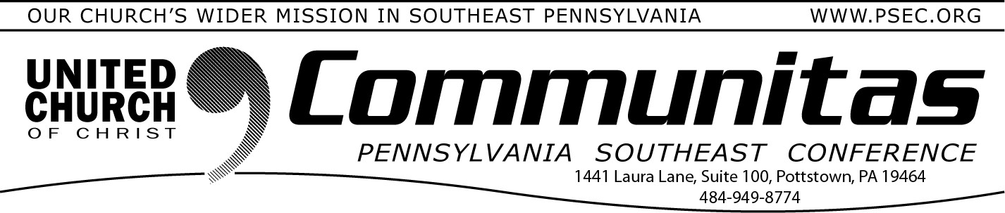May 18, 2025

**REGISTRATION CLOSES TOMORROW AT MIDNIGHT**

**PSEC Spring Annual Meeting**

**May 31, 2025**

**9:00 am—4:30 pm**

**@ Zwingli UCC, Souderton**

**Registration for in person attendance with lunch** for the Spring Annual Meeting of the Pennsylvania Southeast Conference of the United Church of

Christ—the second to last meeting of our historic Conference **will close tomorrow!**

Totals must be given to the caterer.

We will gather in faith, fellowship, and forward-thinking mission. This year, we celebrate our shared commitment to God’s calling, exploring new opportunities for ministry in the Keystone Conference, and

strengthening the bonds that unite our churches and people in

service and love. Come to a time of worship, learning, and collaboration to inspire your faith in the abundant grace that keeps this world.

**To register:** Go to psec.org, click on the *2025 PSEC Spring Meeting*

slider at the top of the page.

**Closure/Celebration Final Meeting**

**of the PSEC**

Save the date of Saturday, November 8th for the final meeting of the PSEC. The location of this very significant event will take place at

St. Paul’s Amityville.

**300th Anniversary Celebrations of**

**the German Reformed Church in America**

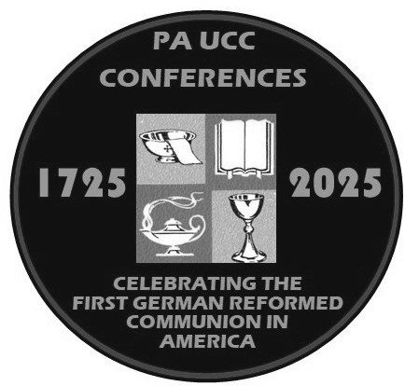This year we will celebrate the 300th Anniversary of the German Reformed Church in the United States which began with the first communion at Falkner Swamp, Oct. 15, 1725. This celebration of our immigrant heritage is particularly mean- ingful and instructive given the current conversations about immigration happening around the nation.

To celebrate, a series of events and worship celebrations are planned, including (among other things) quarterly presentations of German

Reformed History, a liturgy for congregations to share on the morning of Sunday, Oct. 12 and a Festival of Celebration on Wednesday, Oct. 15.

Registration is now open for the first free Historic ONLINE Presentation, May 27 on Zoom at 7:00p. Rev. Rick Taylor will present on "**An**

**Immigration Story: How we got to where we are**." Rev. Taylor will

speak on how German individuals found their way to European colonies

in America in the 1700s.

Mark your calendars for other Historic Presentations:

June 24: A Living Theology: Thinking about God in the Reformed tradition (Rev. Dr. Lee Barrett)

September 25: United and Uniting: How the UCC Makes Room for German Reformed and Armenian Evangelical Christians (Rev. Dr. Heather Ohaneson)

October 28: A Lasting Legacy: Gifts of the Reformed Tradition to the emerging church (Dr. Randall Zachman)

For free registrations and information on all the events, visit the [**300th**](https://yqw8o48ab.cc.rs6.net/tn.jsp?f=001d4G1L9Jjn8h4n-qeurEPx_8di_KvFNp3u-wk8qleH2EwSHp7QwA2jAQnYRRQlbULbT5qMHzbpFUTSoTc6ZEafDzcagmijC8s154D-K0wVWAXBHrdF54J5drYGW2ayR49y1l8XEhr7g_S5urcppO6mn9Rxz6lZy_IHLE4xs8LoN75NOGFaqcdONfqIpGIJSNxUOAySu8ofjqvZBl-cw1_rs4G7M)[**Anniversary Celebrations page**](https://yqw8o48ab.cc.rs6.net/tn.jsp?f=001d4G1L9Jjn8h4n-qeurEPx_8di_KvFNp3u-wk8qleH2EwSHp7QwA2jAQnYRRQlbULbT5qMHzbpFUTSoTc6ZEafDzcagmijC8s154D-K0wVWAXBHrdF54J5drYGW2ayR49y1l8XEhr7g_S5urcppO6mn9Rxz6lZy_IHLE4xs8LoN75NOGFaqcdONfqIpGIJSNxUOAySu8ofjqvZBl-cw1_rs4G7M)of our website for more information. Do this by going to psec.org and clicking on the 2nd slider at the top of the home page.