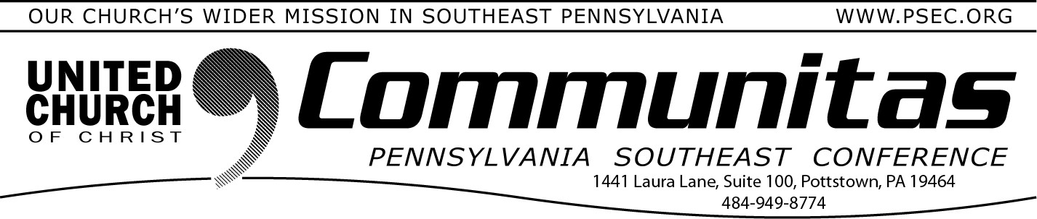March 30, 2025

# What are you willing to sacrifice in the name of freedom?

Greetings,

51 years ago, a young boxer from Louisville, KY, shocked the world by beating Sonny Liston to become the then youngest heavyweight champion of the boxing world. Cassius Clay was his name and little did we know, that loudmouthed kid would eventually become a champion

for human rights and the most recognizable worldwide face of the 20th century.

I am writing this to you from Louisville and I can't help but find motivation from Muhammad Ali and the courage he displayed through- out his career. Ali sacrificed what would have been his best

years physically, refusing to be drafted and in his words, "Go and fight another poor, brown people." **I am wondering, in these days of**

**darkness, what are you willing to sacrifice in the name of freedom!**

I believe, those of us who profess to favor freedom, must be willing to

make sacrifices over the next four years. Frederick Douglass said

power concedes nothing with a demand. The tyranny of our current presidency must be met by courageous people who are willing to make sacrifices in the name of freedom and justice!

*Rev. Cean R. James*,

Associate Conference Minister for Congregational Development

# Closure/Celebration Final Meeting

**of the PSEC**

Save the date of Saturday, November 8th for the final meeting of the PSEC. More details will be forthcoming.

# LAY LEADERSHIP CONVOCATION 2025

***Theme: New Wineskins for New Wine***

Saturday, April 26

Christ Church UCC—1003 W. Marshall St., Norristown

*an occasion for inspiration, education, and community building*

Keynote speaker: Rev. Cean James, Associate Conference Minister for Congregational Development, Pennsylvania Southeast

Register at: [https://layconv25.eventbrite.com](https://layconv25.eventbrite.com/) Cost: $40.

8:30-9:00 a.m. - Registration and coffee

9:00-9:45 a.m. - Keynote Address by Rev. Cean James: “New Wineskins for New Wine”

10:00-11:15 am - Workshops - Select 1 only

1. Worship and Music for Today’s Church - Rev. Cean James
2. The New Keystone Conference - Rev. Bill Worley—What does it mean for your church and for the mission of the church
3. Meetings that Matter - Rev. Beth Lyon—Learn how your

governing board meetings can foster spiritual growth for your leaders, focus on decisions that matter, and get you home at a reasonable time.

11:30-12:45 - Workshops - Select 1 only

1. Worship and Music for Today’s Church - Rev. Cean James
2. Creating and Maintaining Small Groups - Rev. Kevin McLemore
3. How Does the UCC Work - Rev. Bill Worley 12:45-1:45 Lunch

1:45-3:00 - Workshops - Select 1 only

1. Is There a U.C.C. Style of Evangelism? - Rev. Cean James
2. You Are Not Alone - Rev. Kevin McLemore

Ways of congregations working together to more effectively do what they cannot do on their own.

1. New Ways of Approaching Generosity - Generosity Team
2. Gender Identity Awareness - Rev. Sarah Carpenter

**Deadline to register w/ lunch: April 13th**