# Churches Needed to Assemble

**Hygiene Kits and Cleanup Buckets**

November 10, 2024

# Lay Leadership Support Group

The Lay Leadership Support Group , open to all church leaders is a group that gathers once a month on Zoom – **so please join them at their next meeting November 30th at 10:00 am.**

They have found it to be a great place to form

new friendships, to gain support, and to be educated on a variety of topics concerning our churches. The discussions are centered around sharing valuable information about what our churches are doing or maybe could bedoing. This meeting will be online to make ease of attendance for all!

All past attendees will automatically receive an email with the zoom link the Thursday, prior to the meeting. If you are new to the group, please reach out to Susan at the PSEC office at [susan@psec.org](mailto:susan@psec.org) to be added to the list. You may also get the information by going to Nov.

Following recent hurricanes in the southeastern US, 400 cleanup buckets and 650 hygiene kits that were held in PSEC were deployed to those sites. That

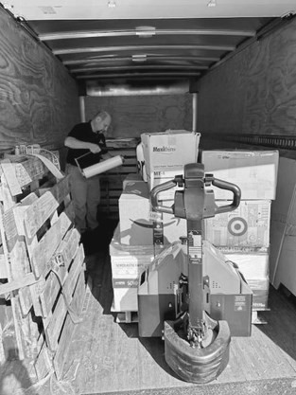shipment has a value of more than $40,000. Thank you to everyone who helped assemble those!

The good news is we had those buckets and kits to send, the opportunity that provides is….we have

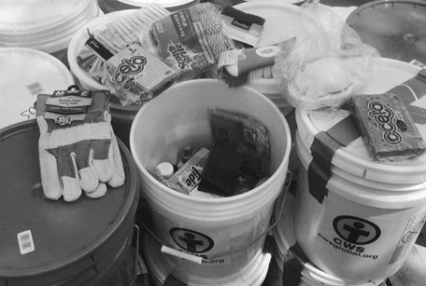depleted our inventory, so your help is needed.

If your congregation is interested in

assembling cleanup buckets, you can receive a [matching grant through the Global HOPE](https://yqw8o48ab.cc.rs6.net/tn.jsp?f=0015TeujBPGx6XhJzbhZ-8vAdH3e7IdDJ7k4I3wdfLn7NW0fb-AiSIrHVGCY6MAOkRJTgszEesU6E-UE0mWnTj4OFH3pimjA_fNRrklRqESjqz75Aw-iIa6-IixwZCfNIWZqCLt3ppWhg9MXWcNaWtqPcM2Qeu7hTmzXuKbpY67IAp0kDFEEMxocp_AZt9Sb-jNo0JFBl98dizegyebZHAEKg%3D%3D&c)

[office.](https://yqw8o48ab.cc.rs6.net/tn.jsp?f=0015TeujBPGx6XhJzbhZ-8vAdH3e7IdDJ7k4I3wdfLn7NW0fb-AiSIrHVGCY6MAOkRJTgszEesU6E-UE0mWnTj4OFH3pimjA_fNRrklRqESjqz75Aw-iIa6-IixwZCfNIWZqCLt3ppWhg9MXWcNaWtqPcM2Qeu7hTmzXuKbpY67IAp0kDFEEMxocp_AZt9Sb-jNo0JFBl98dizegyebZHAEKg%3D%3D&c) For more information on cleanup buckets and drop-off locations, go to psec.org and

search “church world service buckets” .

# Handbook for Visitation

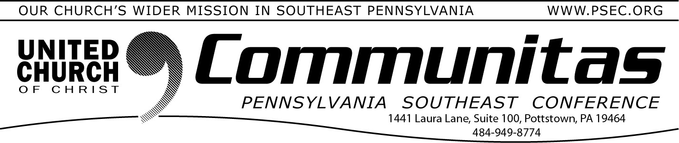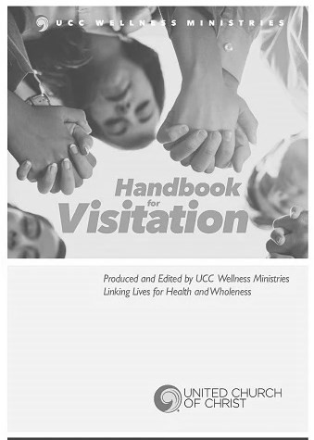30th on the PSEC Calendar on the PSEC website (psec.org). This invaluable Handbook is designed to support those

doing visitation, whether experienced or new to this ministry. Our role in connecting with people on behalf of the church is not just a responsibility but a significant and valued part of ministry, this

*Handbook* will guide and empower you as needed. As church representatives, we are entrusted to share God's love and comfort with those in need

while honoring their unique life experiences and perspectives.

The quotes from scripture, various prayers, and blessings cover many situations, and the blank pages allow you to add your own favorites.

Thus, it becomes a handy reference booklet for those unexpected occurrences.

Obtain this handbook at uccresources.com for a nominal fee.

Donations can be sent to the PSEC office. They will be forwarded.