**Keystone Working Group – Bulletin Insert 4**

“Together We Are Stronger”

# A Vision for Associations

Did you know? Your church belongs to a group of other UCC churches grouped together in what is called an Association. When the UCC was formed in 1957 much of the authority in the new

denomination was vested in the Associations, including the care of local churches within each one. Part of that commitment to care included helping churches when they were in difficult or troublesome circumstances. Over time, however, the task of caring for

congregations in times of need moved into the hands of Conference staff, and away from Associations.

In looking toward a Keystone Conference, we know that Conference staff numbers will be reduced. Therefore, care for congregations will need to move back to members and leaders of Associations who will now be supported and resourced by

conference staff. Currently, Association Presidents are meeting with representatives from the Keystone Working Group to draft what that work might look like for our Associations. This is largely human resource work to build teams of trained leaders.

Just as the Conferences are in formal discussions for a merger and shared

leadership, the Keystone Working Group encourages those types of conversations among our Association leaders too!

***“We were talking to our churches about now being the time for shared ministry and realized we need to be talking about this at the conference level too.”***

*~ Rev. Carrie Call, Penn Central Conference Minister*

# Next Town Hall Sessions

The conversations around the timeline, the ministry of Associations are available for registration. Please use the QR code,

on all conferences’ websites or conference office.

In each townhall conversation, the timeline will be reviewed for possible action toward our vote, the motion to the General Synod and next steps.

# Merger Motion Vote by 4 Conferences Nov. 9, 2024

Each congregation is allowed their usual number of delegates to vote on the merger motion. See each conference for details to register, participate and make your vote count! The full motion is available on the website.

For more information: <https://psec.org/keystone/>

# Motion to General Synod, July 11-15, 2025

If approved by all 4 conferences, the motion is presented to General Synod for UCC delegates’ approval.

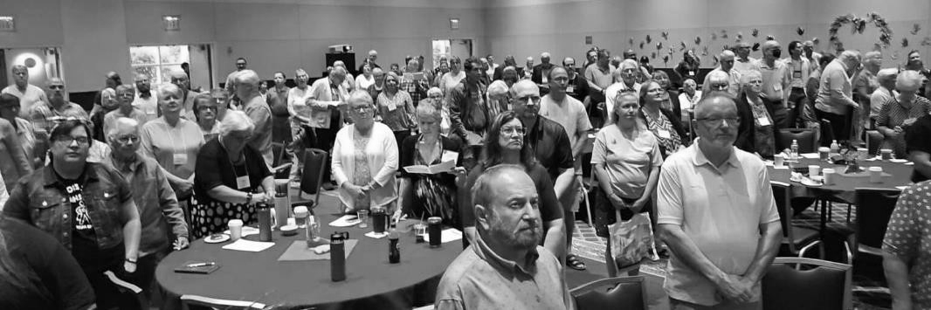

***“We face the unknown, but God is known!”***

-- Rev. Dr. Karen Georgia Thompson

President and General Minister of the UCC to the delegates at the gathered PA area conferences.