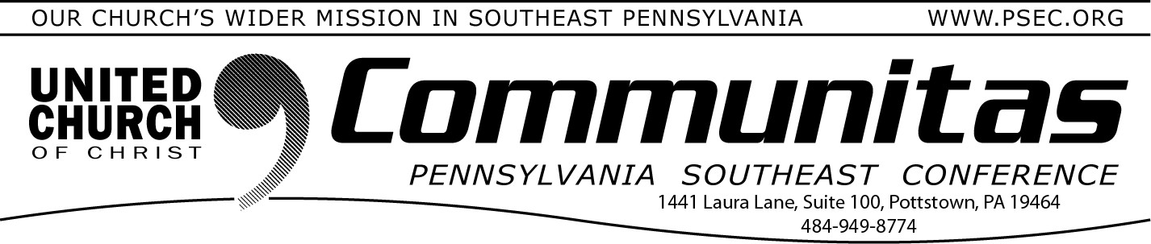

August 25, 2024



**Tropical Storm Debby brought heavy rains to much of Pennsylvania**. The hardest hit areas were in Penn Central Conference - Tioga, Potter, and Lycoming Counties. However, heavy rains caused flooding for

residents all over Pennsylvania.

In response, Pennsylvania Voluntary Organizations Active in Disaster

(PAVOAD) (of which PSEC is a part) and Crisis Cleanup have set up a call center to streamline recovery efforts. This call center aims to efficiently coordinate volunteer assistance for muck out operations, tree removal and debris cleanup for affected residents.

[Crisis Cleanup](https://api.crisiscleanup.org/login/?utm_source=grice%20connect&utm_campaign=grice%20connect%3A%20outbound&utm_medium=referral) is a renowned disaster work order management platform that facilitates better coordination among relief organizations, minimizes duplication of efforts, and enhances the volunteer experience.

**Anyone who needs help with cleanout should call the Crisis Cleanup Hotline 1-844-965-1386**.

**Successful activation of Crisis Cleanup relies on a pool of call center volunteers. We are actively recruiting volunteers to help take**

**calls.** Volunteers take calls on their own time and from their own laptop and phone, without making your phone number available to the caller. The call center is scheduled to close on August 23, 2024.

**If you are interested in supporting the call center,** please contact PSEC Disaster Response Coordinator, Karl Jones, 570-617-4018 or

[kjones275@comcast.net.](mailto:kjones275@comcast.net) He will be happy to set you up!

# Conference Minister on

**UCC Article on Possible UCC PA Conference Merger**

Recently the four PA Conference Ministers met with Kayla Berkey, a

journalist with our UCC News Team, to talk about the possible coming together of the four PA Conferences. She captured our hour-long

conversation for publication in [UCC News.](https://yqw8o48ab.cc.rs6.net/tn.jsp?f=001G3NS_t1cmknzdQHhXPSStBzwidUdwzfVn0duvbwvK6ArGy_-SPCdHrDz7SJE3zsW7_76DETPUHgLrDXwu24A6oCU_BvAcwI4Jjyi8O2RpasQQihjaRNLcF8xntj2220UF2SZFiwb8bIIGrgQ6dCghbkeSSL-VbW-XvpITBDp43tJ3RcKV_3-LQjS6tC8dRUxDVC3oIindXrrDQNE9VMG_l5IAh)

(https://[www.ucc.org/ucc-conferences-in-pennsylvania-make-moves-](http://www.ucc.org/ucc-conferences-in-pennsylvania-make-moves-) toward-new-keystone-conference/) It was a lot of information to

summarize in 800 words and she did that well.

What is missing from the article, and from my recollection of our

conversation, is any deep reflection about how God and the Holy Spirit have been at work through this process. God is. In revelations for the Keystone Working Group as well as moments of distress that did not

become debilitating. In countless holy moments at the combined June Conference meeting which could have gone sideways in a thousand

different directions but didn’t. In the faith and courage of so many to venture into the wilderness of unknowns trusting that God can make something marvelous of merger— in spite of us and because of us. In ways our vision, dimmed by the travails of the material world, cannot yet see.

I confess to God and to you that I get so caught up in the doing of my work I rarely take the time to be aware of, and to thank, the ONE who is sustaining me through it. My wise friend, Nate Baxter, was right — “It’s easy to lose sight of God when you’re doing God’s work.” I need your help with that as I suspect you need mine. That’s what it means to be the church. However we organize that on Earth, I pray it reflects something of heaven.

With prayers for you,

Rev. Bill Worley, Conference Minister

# SAVE THE DATE:

**PSEC Fall Meeting—Nov. 9th @ 10:00 am** @ Good Shepherd UCC/Tuckerton (Reading, PA) Votes will be taken on:

1. 2025 PSEC Budget
2. Possible UCC PA Conference Merger