**August is**

**National Make a Will Month**

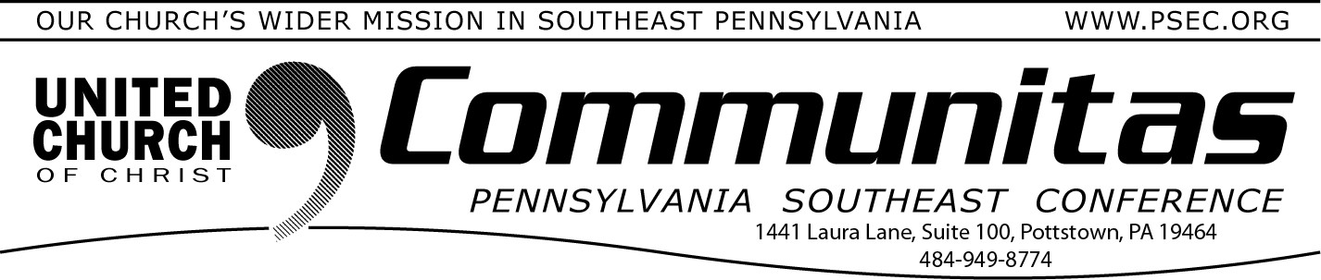August 18, 2024

**Lay Leadership Support Group**

**Now Open to ALL CHURCH LEADERS**

A Lay Leadership Support Group has existed for several months now,

but **a change has been made!**

***The group is NOW OPEN to ALL Lay Leaders, not just Consistory members!***

The group gathers once a month on Zoom – **so please join them at their next meeting September 7th at 10:00 am.**

They have found it to be a great place to form new friendships, to gain support, and to be educated on a variety of topics concerning our churches. The discussions are centered around sharing valuable information about what our churches are doing or maybe could be

doing. This meeting will be online to make ease of attendance for all!

All past attendees will automatically receive an email with the zoom link the Thursday, prior to the meeting. If you are new to the group, please reach out to Susan at the PSEC office at [susan@psec.org](mailto:susan@psec.org) to be added to the list. You may also get the information by going to Sept. 7th on the PSEC Calendar on the PSEC website (psec.org).

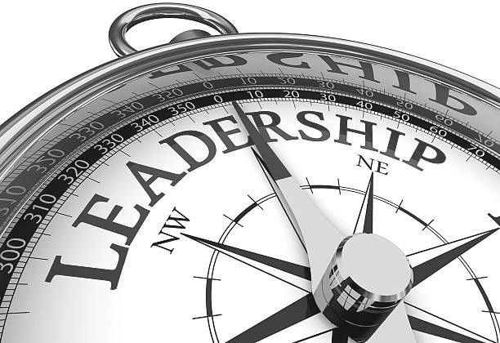New attendees welcome!

The National Ministries and the Pension Boards partnered to bring [**Free**](https://support.ucc.org/page.redir?target=http%3a%2f%2fwww.freewill.com%2fucc&srcid=12773&srctid=1&erid=1425761&trid=1e2312b2-0315-4bb3-84a9-cfdf49520faa)[**Will**](https://support.ucc.org/page.redir?target=http%3a%2f%2fwww.freewill.com%2fucc&srcid=12773&srctid=1&erid=1425761&trid=1e2312b2-0315-4bb3-84a9-cfdf49520faa)(freewill.com/ucc) resources to the United Church of Christ,

helping individuals and families to create legally valid wills at no cost (or draft one for their lawyer’s review).

The partnership grew from a commitment to make it easier for our donors to create a lasting legacy for the people and the charitable causes closest to their hearts. We also wanted to ensure all our

congregations and church settings had crucial tools for promoting

planned giving.

The partnership between the National Ministries and The Pension Boards embodies our mutual commitment to covenant.

Together, we all rise.

**From the Addiction & Recovery Taskforce:**

**Barriers to Treatment**

Some people struggling with substance abuse disorder are not receiving help because of barriers to treatment. Beyond what we normally think of as determinants of health such as diet, exercise and genetic makeup, there are also social determinants of health such as socioeconomic status, education, housing, neighborhood conditions, employment,

social support networks, and access to healthcare. Problems in any of these areas can prevent a person from being able to access care for addiction.

We can assist by being aware of the resources in our communities that can help those who have these issues to find the connections they need to address these barriers and help them to get to the care they need for their addiction.