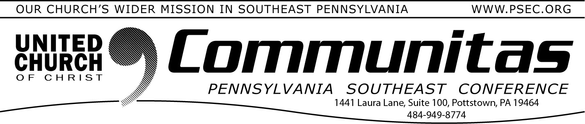
May 12, 2024

Mothers’ Day Message
by Rev. Cean James
Associate Conference Minister for Congregational Development

In II Kings Chapter 4, there is a young boy who instantly grows ill one morning while working in the field with his father. When his father is alerted to his son’s condition, this is his simple reply, “take him to his mother.” As Mother’s Day approaches, it is with thankful hearts that we consider all the women in our lives who are like that Shunamite woman. Whether they are mothers, grandmothers, aunties, sisters, teachers, coaches or pastors, each of us somewhere in our lives, have been blessed by women who have a way of caring for us that money and insurance cannot buy. Mother is a doctor, dentist, chef, professor, therapist, lawyer, tailor and banker. To all the woman who are called upon with life gets challenging, Happy Mother’s Day!

Strengthen the Church Offering next week
Many churches in the United Church of Christ collect the Strengthen the Church offering on Pentecost Sunday (this year that’s next week, May 19). The Strengthen the Church (STC) Offering reflects the shared commitment of people across the United Church of Christ to cooperatively build up the UCC. Conferences and the national setting equally share the gifts given by members and friends through their local congregations.

The funds raised support leadership development, new churches, youth ministry, and innovation in existing congregations. By your generosity to this offering, you build up the Body of Christ.

As God calls our congregations to be the church in new ways, your generosity will plant new churches, awaken new ideas in existing churches and develop the spiritual life in our youth and young adults.

If your congregation does not regularly collect Strengthen the Church offerings, consider asking your church leadership to consider it, or you can give personally by visiting psec.org and clicking Donate in the upper right corner.

Fill in when your pastor is on vacation
PSEC maintains a Sunday Supply list of clergy who are available when pastors are on vacation. During the summer months it can be harder to find someone to fill in, when many clergy are taking vacations. Have you ever considered supporting your pastor by preaching when they’re on vacation?

Among the many resources on our “Resources for Lay-led Worship” page (psec.org/worship), are sermons that can be read when your pastor is on vacation or training videos if you want to try writing your own sermon. Consider helping your pastor this vacation season by offering to fill in for them.

