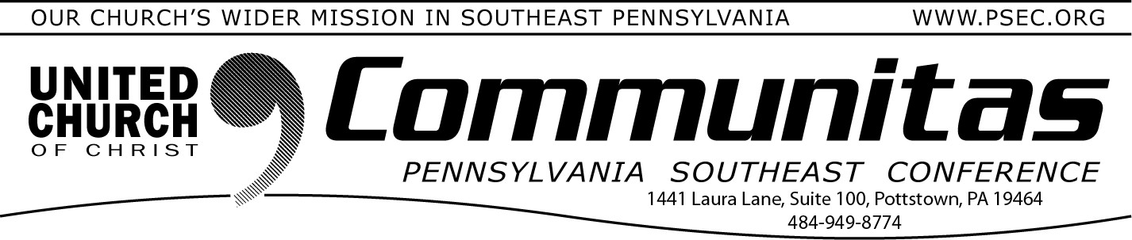
From the Addiction & Recovery Taskforce: AMA Overdose Epidemic Report 2023
May 5, 2024

Registration FOR EVENT ONLY Extended Annual Meeting 2024
“Together We Are Stronger”
June 7-9

Registration for our upcoming Spring meeting is extended to May 31st BUT THE ROOM BLOCK DEADLINE FOR OVERNIGHT ROOMS IS STILL MAY 6th
No one will be able to help you with a room after May 6th and the rates do skyrocket!
Join PSEC and the other three Pennsylvania UCC Conferences for a weekend of discernment of our four conferences coming together as
one. Including workshops, affinity group gatherings, worship, a mission project, fellowship and relationship building.

Each conference will hold its own business session Saturday morning.
Go to the PSEC website (psec.org) and click on the Annual Meeting
slider on the opening page to be taken to an agenda, instructions on how to receive the registration discount and more!
If you are having any issues with getting your overnight room or
registering, please reach out to Susan at the PSEC office at psec.org or
by calling 484-949-8774 opt 1.
Naloxone is a harm reduction success. Harm reduction aims to minimize the negative health, social and legal impacts associated with drug use. If
it wasn’t for naloxone, tens of thousands — if not hundreds of thousands
— of Americans would be dead today. The AMA strongly urges support for the following:
- Naloxone in schools.
- Naloxone in public settings.
- Updated naloxone access laws. (AMA Report 2023)
If you do not have Naloxone available at your church, please contact us. Our contact information is online at the PSEC website, psec.org.

Bethany Children's Home is in Need of Bedding

Each youth that arrives at Bethany Children's Home needs sheets, a pillow case and comforter for a twin sized bed. If you'd like to donate please send donations to 1863 Bethany Rd. Womelsdorf, PA 19567.
Or donate online at https://givebutter.com/BCHeroes and put "bedding" in the notes!
You can also order directly off Amazon using the following link:
Sweet Home Collection 5 Piece Comforter Set Bag Solid Color All Season Soft Down Alternative Blanket & Luxurious Microfiber Bed Sheets, Gray, Twin https://a.co/d/0XYeUI5 Ship it to Bethany Children’s Home, 1863 Bethany Rd., Womelsdorf, PA 19567

