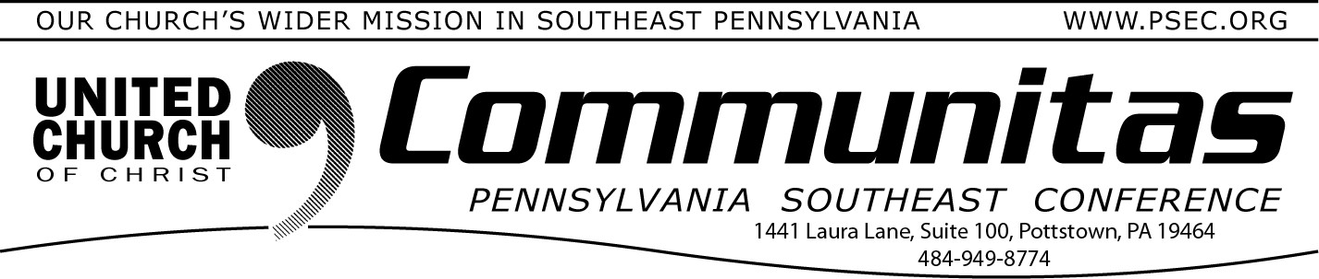
Lay Leadership Support Group - Via Zoom!

April 28, 2024

Only 7 More Days to Register Annual Meeting 2024 “Together We Are Stronger” June 7-9
Join all four Pennsylvania UCC Conferences for a weekend of
discernment of our four conferences coming together as one. Including workshops, affinity group gatherings, worship, a mission project,
fellowship and relationship building.

Each conference will hold its own business session Saturday morning.
Go to the PSEC website (psec.org) and click on the Annual Meeting
slider on the opening page to be taken to an agenda, instructions on how to receive the registration discount and more!

One Town Hall Discussion Remains on Potential Conference Merger
There is one remaining opportunity to attend a Town Hall Discussion on the Keystone Study Group. This event will provide a chance to share questions and observations. Please make sure you have viewed the Key- stone page (https://psec.org/keystone/) on our PSEC website prior to joining the meeting.
May 2 at 2:00p - Facilitated by Associate Conference Minister Rev. Kevin McLemore
Sign up by going to psec.org and clicking on the Events & News tab and then opening the calendar and clicking on May 2nd.
A Lay Leadership Support Group exists for
Consistory Presidents as well as those serving on Consistory. We gather once a month on Zoom – so please join us at our next meeting May 11th at 10:00 am.

We have found it to be a great place to form new friendships, to gain support, and to be educated on a variety of topics concerning our churches.
If you are new to the group, please reach out to Susan at the PSEC office at susan@psec.org to be added to the list. New attendees welcome!

PNEC Invites you to their

Faith Formation Leadership Retreat May 3 - 5, 2024
Spruce Lake Retreat Center
5389 Route 447, Canadensis, PA 18325
COST: $195/person
(includes all programming and 3 meals on Saturday and Sunday breakfast)
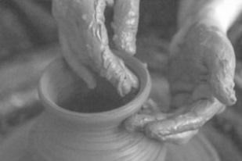
This retreat for adults involved in Faith Formation provides an opportunity for those wishing to collaborate, rejuvenate, and innovate their approach to Faith
Formation! This retreat will provide
practical education around faith formation and we4lcomes volunteers as well as folks
working in the church to participate and learn. Set in the scenic Spruce Lake Retreat Center, this promises to be a relaxing and informative
time!
To register, email Patty at the PNEC office at pattyr@pnec.org. Any questions, contact Rev. Janet Newett at pastorjanetn@gmail.com.

