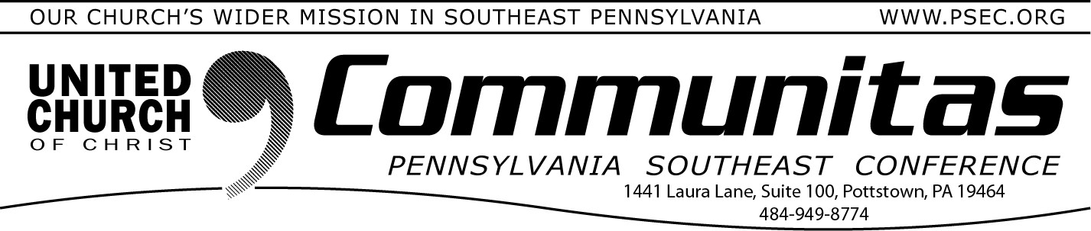
April 21, 2024

One Town Hall Discussion Remains on Potential Conference Merger
There is one remaining opportunity to attend a Town Hall Discussion on the Keystone Study Group. This event will provide a chance to share questions and observations. Please make sure you have viewed the
Keystone page (https://psec.org/keystone/) on our PSEC website prior to joining the meeting.
May 2 at 2:00p - Facilitated by Associate Conference Minister Rev. Kevin McLemore
Sign up by going to psec.org and clicking on the Events & News tab and then opening the calendar and clicking on May 2nd.

From the Addiction & Recovery Taskforce: Drug Take Back Day
The 26th National Prescription Drug Take Back Day is Saturday, April 27, 2024. There will be local sites available in your local area. You can find locations online or call your local police station or drug store. Keep
unused prescription out of the hands of our youth and others.

47 Days Until the
Annual Meeting 2024 “Together We Are Stronger” June 7-9

Are your Clergy and Church Delegates Registered?

Join all four Pennsylvania UCC Conferences for a weekend of
discernment of our four conferences coming together as one. Including
workshops, affinity group gatherings, worship, a mission project, fellowship and relationship building.

Each conference will hold its own business session Saturday morning.
Go to the PSEC website (psec.org) and click on the Annual Meeting
slider on the opening page to be taken to an agenda, instructions on how to receive the registration discount and more!

Worship for Churches to use on June 9
The Conference Ministers of the four Pennsylvania Conferences have prepared a worship liturgy and sermon for use in churches on Sunday, June 9. This will allow clergy and church delegates to remain for the entire Annual Meeting. The materials align with Rev. Dr. Karen Georgia Thompson's theme for the Sunday worship at Annual Meeting. The
worship at Annual Meeting will be recorded, but not livestreamed. Churches' lay leaders can use the following liturgy and sermon manuscript that morning.
Find this liturgy by going to: https://psec.org/annual-meeting-2024/ and scroll to the bottom.

