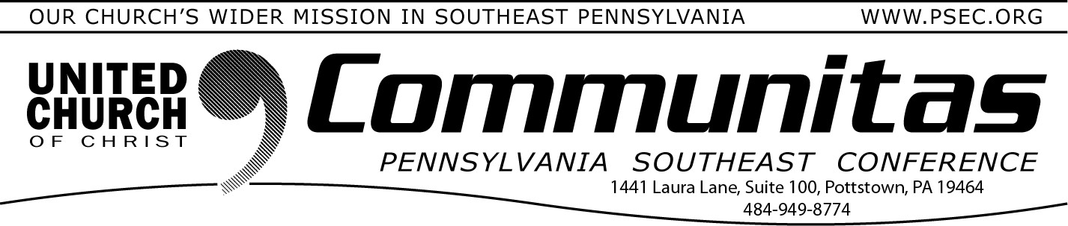
Keystone Working Group – Communications Summary of March 15, 2024 Meeting
April 14, 2024
The Keystone Working Group* (KWG) discussed how we can reaffirm WHY we welcome this move of the Holy Spirit to empower our conferences. We
believe that because of our foundation in Jesus Christ, “Together We Are
Stronger!”
Over the last two years, relationships have been meaningful and energizing, creative and inspiring. As new people and voices have come to be part of the group, we’ve grown to appreciate the collaboration. We pray you are inspired by this hopeful vision!

For the June 7-9 Gathering, a Delegate Booklet is being prepared containing
all foundational documents, frequently asked questions and more. We worked on discussion plans for both individual conferences’ conversations and our combined plenary sessions, to engage with the Holy Spirit and each other in our discernment.
Conference Ministers and Task Groups shared updates on their conversations and draft documents:
Staffing – A Staff Retention Statement has been prepared. A possible model structure accommodating the many ministries, and number of congregations in those regions, has been developed in consultation with current staff of the 4 conferences.
Governance –In anticipation of an affirming vote on a merger resolution in November 2024, a Governance and Ministry Model is being developed for a proposed Conference Board with persons nominated from the various regions to create balance of skills and abilities and an equitable representation from the current conferences.
Finance – The team has reviewed all 2024 budgets and assets, including consolidated endowments. Collective funding for Our Church’s Wider Mission giving is trending a 4% decrease per year across all areas.
Approval Process – In consultation with UCC National, a draft MOTION is recommended rather than a resolution to Synod 2025. The Approval Process sub group is revising the draft presentation and will present again in April. For our collective conversation and discernment, the motion will be shared as part of the 4 conferences’ combined
gathering in June.
Legal – This subcommittee has not yet met, pending Governance and Finance considerations.

The Keystone Working Group’s enthusiasm continues to build as we explore the strategic vision and scale of opportunity before us to live into the WHY and HOW of “Together We Are Stronger!” KWG meets next to focus on details of the upcoming June gathering, with additional focus on the hard questions of what we believe the 4 conferences merged can afford for staffing, program and offices. Leadership from UCC’s Join the Movement will help us intentionally
prepare for a proposed new conference staff and leadership reflecting the diversity of our commonwealth, the equity we strive to show in ministry and the inclusion we want to present as followers of our all-inclusive Christ. We look forward to exploring God’s “new thing” among us.

REGISTRATION INFORMATION is now available through all 4 conference
websites, with financial assistance available as needed. (PSEC is offering a 75%
discount on registration. PLEASE READ INSTRUCTIONS!!)
The combined gathering of all 4 conference areas is June 7-9, 2024 at State College. The group plenary sessions starting at 9am Saturday morning will significantly guide our collective work and individual conference discussion.
Because of our shared foundation in Jesus Christ, the affirmation of Together We Are Stronger continues to drive our thinking and empower our spirit.
Please visit the Keystone Conference Project website hosted by the PSEC at https://psec.org/keystone/ .
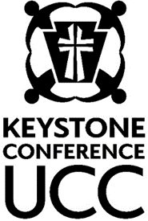
Please share questions and comments by email at Keystone.Conference.Project@gmail.com or direct mail through your own area Conference Office.

Sharing our progress relying on the grace of God!
KWG Communications Team

