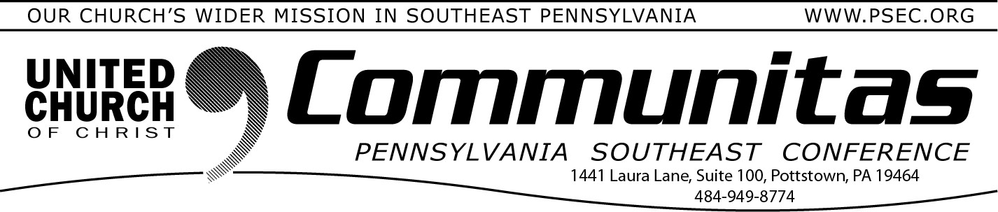
Town Hall Discussions Scheduled on the
Keystone Study

April 7, 2024

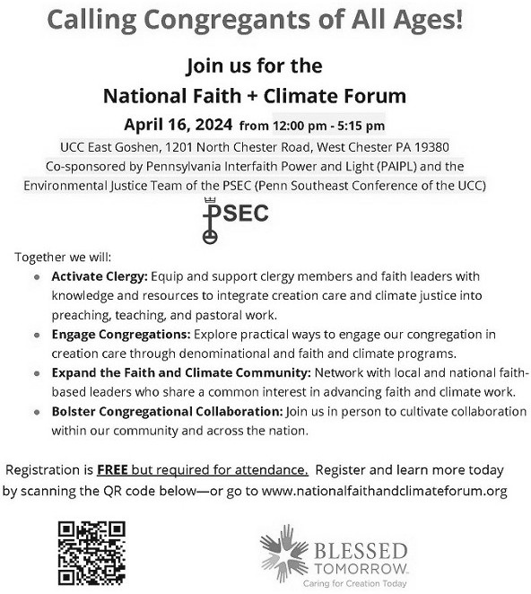
There are three upcoming opportunities to attend a Town Hall Discussion on the Keystone Study Group. These will provide a chance to share questions and observations. Please make sure you have viewed
the Keystone page on our PSEC website prior to joining the meeting. Each of the Town Halls will share the same information. All three presenters are members of the Keystone Working Group.

April 11 at 7:00p - Facilitated by Associate Conference Minister
Rev. Cean James
April 16 at 2:00p - Facilitated by PSEC Vice-moderator
Rev. Melissa Burkhart
May 2 at 2:00p - Facilitated by Associate Conference Minister
Rev. Kevin McLemore

To register, free registration, go to psec.org and click on the Calendar under the Events & News Tab and then click on the date of the meeting you would like to attend.

June 7-9, 2024
2024 Spring Annual Meeting
@ The Penn Stater Hotel & Convention Ctr.
215 Innovation Blvd, State College, PA 16803

Our 2024 Spring Annual Meeting will be part of the …
“Together We Are Stronger”
Keystone UCC Conferences June Meeting

For more information and the link to registration:
https://psec.org/annual-meeting-2024/

