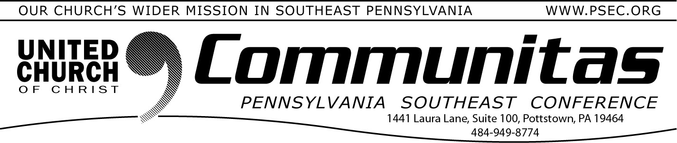
March 24, 2024

Keystone Working Group --

Summary of February 16 meeting
Meeting February 16 by Zoom, the Keystone Working Group discussed ongoing efforts to share information with all the congregations across our four regions with our website (psec.org/keystone/). Delegates will receive a booklet containing our “Story of Why We Are Here” and
theological statements and rational for our merger. It will contain re- sponses to Frequently Asked Questions. To prepare for our June 7-9 Gathering, we discussed plans for the combined plenary sessions. We
want to encourage conversation and how we feel the engagement of the Holy Spirit in this process.
The Communications Team also prepared a new video to share the
creative process of a possible new unified Keystone Conference logo. In March, we will present the newly edited video on the website and a link available for all to share in our excitement, believing “Together We Are Stronger!”
Conference Ministers and Task Groups shared updates on their
preparations and initial conversations:
Staffing – A Staff Retention Statement is being prepared in consultation with current staff of all 4 conferences.
Governance – Dates for a possible Transition Plan for Governance is being developed in anticipation of an affirming vote on a merger resolution in November 2024.
Finance – A consolidated baseline budget draft for 2025, a dream
budget and what’s “realistic” at current funding and resource levels, as well as a report of combined assets is being developed.
Additional policy and possible budgets for 2026 and 2027 are also being drafted.
Approval Process – A draft resolution will be proposed in the March meeting, with prayer and editing considerations in April to present as part of the 4 conferences’ combined gathering in June for our collective conversation and discernment.
Legal – This subcommittee has not yet met, pending Governance and Finance considerations.
We continue to share our excitement around the group regarding our plenary sessions, sharing what we have heard from around our four
areas that is compelling and life-giving about coming together. There is growing anticipation for what we can accomplish together. Our
Together We Are Stronger affirmation continues to drive our thinking and empower our spirit.
Please visit the Keystone Conference Project website hosted by the PSEC at psec.org/keystone/. We can always share questions and comments by email at Keystone.Conference.Project@gmail.com or direct mail through your own area Conference Office.
Remember to Save the Date for the joint meeting of all 4 conference areas, June 7-9, 2024 at State College. Registration details and a
Communications Booklet will be available in early March to prepare for the event.
Sharing our progress in grace and hope,
KWG Communications Team
Steve Davis, St. John’s UCC, Fullerton (PNEC) Heather Kurtz, Zion UCC, Arendtsville (PCC)
Deb Long, First Trinity UCC, Youngwood (PWC)
(Open Position), (PSEC)
*A study, discernment and working group of the 4 PA area UCC Conferences.

Wishing you and yours a blessed Palm Sunday and Holy Week!

