A Weekend with Rev. Dr. Sarah B. Drummond

Lay Leadership Convocation
This Year’s Theme: Sharing Leadership

Keynote speaker: Dr. Sarah B. Drummond, Dean of Andover Newton Seminary at Yale Divinity School, New Haven, CT

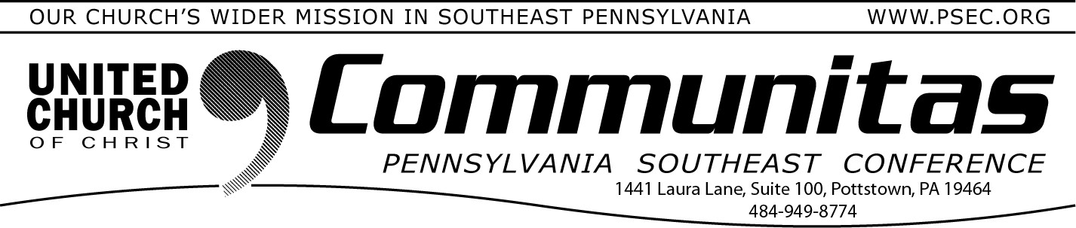
Vote for Climate Hope Art Contest
March 10, 2024
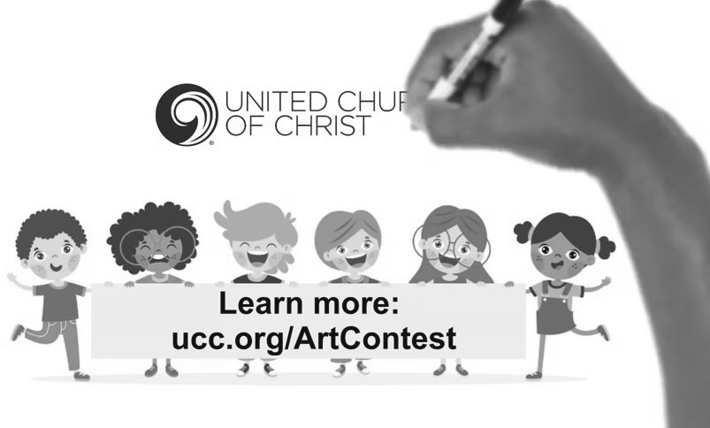
To give our children and youth a voice this election season (while also reminding adults of their responsibility for the next generation when they vote), the UCC is conducting a Vote for Climate Hope Art
Contest. UCC children and youth are invited to draw, paint, or color about the world and the environment in which they want to live. Art submissions can be made from March 1 to April 16.
Learn more at: ucc.org/ArtContest
April 6, 2024
@ Church of the Good Shepherd, Boyertown 8:30 am—3:00 pm
Register at: https://layconv24.eventbrite.com
$40. w/ lunch—$20. w/out lunch
An occasion for inspiration, education, and community building 9:30 - 9:00 am—Registration and coffee
9:00 - 9:45 am—Keynote Address by Dr. Sarah B. Drummond:
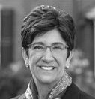
“Shared Leadership” 10:00 - 11:15 am—Workshops
12:45 –1:45 pm—Lunch
1:45 – 3:00 pm—Workshops

Afternoon Workshop Based on Dr. Drummond’s book:
Dynamic Discernment: Reason, Emotion & Power in Change Leadership

April 7, 2024
@ Immanuel UCC, Shillington
2:00—4:00 pm
Register at: https://drdrummond.eventbrite.com Free workshop

Enjoy an afternoon with Rev. Dr. Sarah B. Drummond while she leads a workshop on her book Dynamic Discernment: Reason, Emotion & Power in Change Leadership.
This workshop is designed for both clergy & Lay Leaders to be engaged in practical application for their own settings.

Registration will begin at 1:30

