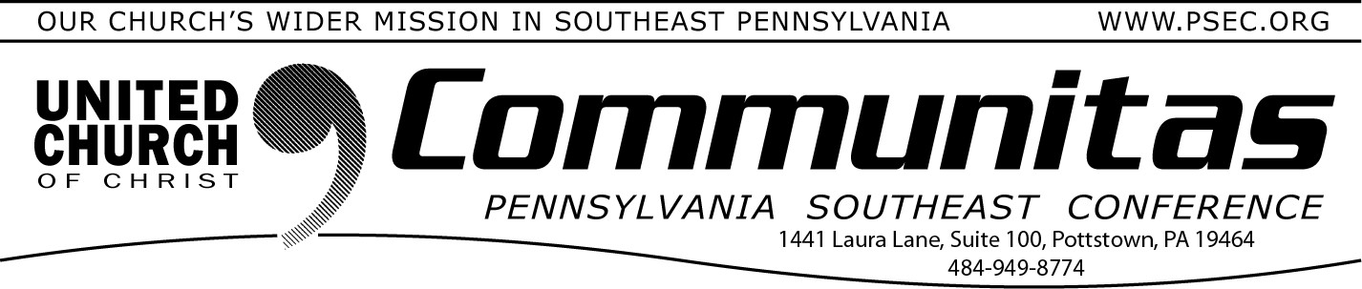
2024 Lay Convocation
February 25, 2024
This Year’s Theme: Sharing Leadership
Keynote speaker: Dr. Sarah B. Drummond, Dean of Andover Newton Seminary at Yale Divinity School, New Haven, CT

April 6, 2024
@ Church of the Good Shepherd, Boyertown 8:30 am—3:00 pm
Register at: https://layconv24.eventbrite.com

An occasion for inspiration, education, and community building 9:30 - 9:00 am—Registration and coffee
9:00 - 9:45 am—Keynote Address by Dr. Sarah B. Drummond:
“Shared Leadership” 10:00 - 11:15 am—Workshops
12:45 –1:45 pm—Lunch
1:45 – 3:00 pm—Workshops

Workshops being offered:
“Differ We Must”: Steps to engage congregations in overcoming differences.
The Spiritual Life of the Church Choir Sharing Leadership
The Keystone Conference: what is it and why does that matter to the people in the pews.
Why Telling Our Faith Story Matters
Accompanying Our Aging Selves: Being Present with Older Adults
Small Sunday School
Engaging the Fringes of the Church How Does the UCC Work Stewardship & Generosity Impact
Churches Sharing a Pastor: An Ancient Model of Ministry for a Contemporary Church.

2024 Stewardship Materials
‘Imagine Together” is the theme for the UCC's 2024 stewardship campaign. This year's theme is "Imagine Together," helping people
understand the impact our congregations can make in our communities.
Materials include eight complete worship
services, hymn suggestions, sermon starters, and faith formation sessions for children, youth, and adults. Also provided are practical tools
such as logos, commitment cards, bulletin inserts, and letters. Print materials or digital downloads available.
Order at uccresources.com.

PNEC Invites you to their

Faith Formation Leadership Retreat May 3 - 5, 2024
Spruce Lake Retreat Center
5389 Route 447, Canadensis, PA 18325
COST: $195/person
(includes all programming and 3 meals on Saturday and Sunday breakfast)
This retreat for adults involved in Faith Formation provides an opportunity for those wishing to collaborate, rejuvenate,
and innovate their approach to Faith Formation! This retreat will
provide practical education around faith formation and we4lcomes volunteers as well as folks working in the church to participate and learn. Set in the scenic Spruce Lake Retreat Center, this promises to be a relaxing and informative time!
To register, email Patty at the PNEC office at pattyr@pnec.org. Any questions, contact Rev. Janet Newett at pastorjanetn@gmail.com.

