our many places of worship to be the starting points for transformation. Aspiration anchored in reality will guide us in meeting our goals.

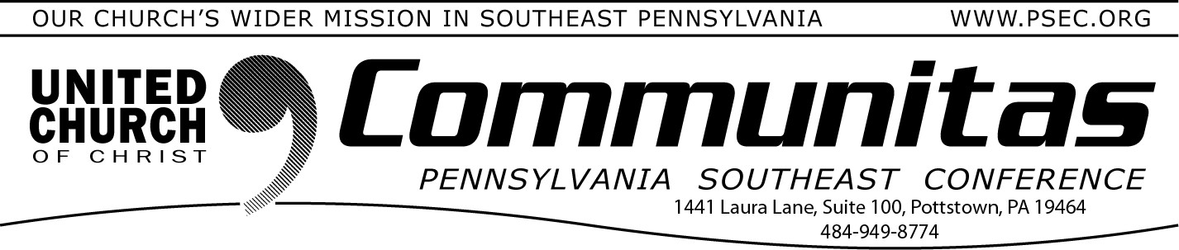
February 18, 2024

Important Updates from the Keystone Working Group
Meeting January 19 by Zoom, we discussed the ongoing process overview. We reviewed the priority of functions to support the ministry of the local church and pastors in ministry settings. Out of all the functions identified, the top 5 functions were (1) Administrative/Legal, (2) Oversight/Authorization, (3)
Pastoral Care, (4) Leadership Training and (5) Search and Call. The Working
Group approved final versions of the Case Statement (Keystone-Case-
Statement-Final.pdf) and Basis for Union (Keystone-Basis-of-Union-Final-Jan- 2024.pdf ) for the Keystone Project website. The Working Group also approved Frequently Asked Questions (FAQs-January-2024-added.pdf ) that consolidated questions and responses from our listening and presentation
gatherings across all 4 conferences. You can find these documents are more information at https://psec.org/keystone/.

The “big tent” has long been a descriptive term for the UCC that means different things to different people. The Working Group affirmed that we
share a diverse spectrum and many commonalities. We strive for consensus and honor each perspective’s faithfulness to remain engaged in conversation. With our varied demographics, our theology and traditions, we embrace our deep commitment to the love of God and neighbor. We believe in this “big tent” way to be the Church! There is a place to be
inspired and call “home” for all in this Keystone Conference “big tent,” because Together We Are Stronger!
Five subgroups will meet and gather more detailed information to share next steps in our progress toward further development of recommendations for a proposed merger of the 4 area conferences. Conference Ministers and Task Groups continue to study issues related to:
Finance Approval Process
Governance Staffing Needs
Legal Issues

Realizing that “Hope alone is not a strategy,” we know that merged
ministries call for more resources to meet our aspirations. We believe any
new conference programming and guidance will better equip and strengthen
We further explored our initial logo presentation and “Keystone Conference” name. We aim to create an image and name that will guide us as we form the new conference. It is important early on to secure domain and social media options to help us clearly and consistently communicate who we are in our process. The new body and governance leadership can then recommend logos and a conference name going forward. The initial logo design of the “Keystone Conference” is also available on the website.

Please visit the Keystone Conference Project website hosted by the PSEC at https://psec.org/keystone/ Your questions and comments continue to help us develop a greater shared ministry. You can always reach us by email at Keystone.Conference.Project@gmail.com or direct mail through your own area Conference Office.

Remember to Save the Date for the joint meeting of all 4 conference areas, June 7-9, 2024 at State College. A Communications Booklet will soon be developed in preparation for the event.
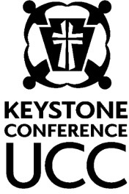
Sharing our progress in grace and hope,
KWG Communications Team
Steve Davis St. John’s UCC, Fullerton (PNEC) Heather Kurtz Zion UCC, Arendtsville (PCC) Bob Fogal Peace in Zion, Zieglerville (PSEC) Deb Long First Trinity UCC, Youngwood (PWC)

*A study, discernment and working group of the 4 PA area UCC Conferences – Penn West, Penn Central, Penn NE, and Pennsylvania SE

Lay Leadership Support Group - Via Zoom!
A Lay Leadership Support Group exists for Consistory Presidents as well as those serving on Consistory. We gather once a month on Zoom – so please join us at our next meeting February 24th, next Saturday, at 10:00 am.

We have found it to be a great place to form new friendships, to gain support, and to be educated on a variety of topics concerning our churches.
If you are new to the group, please reach out to Susan at the PSEC office at susan@psec.org to be added to the list. New attendees welcome!

