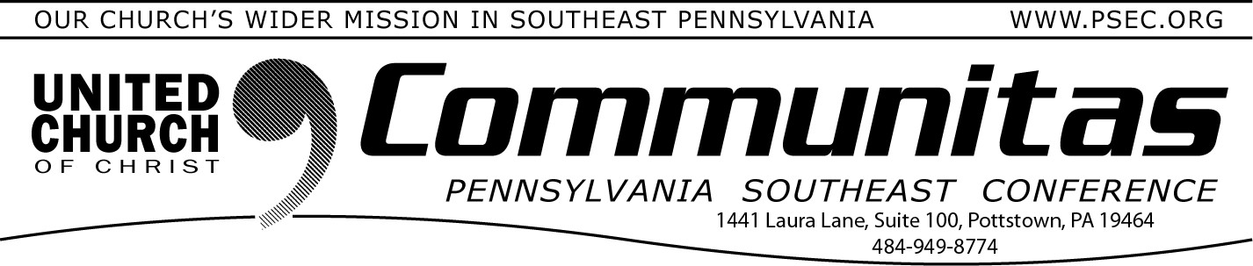
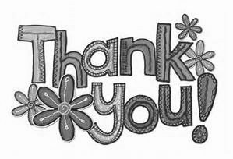
A Weekend with Rev. Dr. Sarah B. Drummond
February 11, 2024
Thank you for the difference you have
made in the lives of people, communities, and pastoral

Lay Leadership Convocation
This Year’s Theme: Sharing Leadership

leadership over the last year through your financial support. Whether you offered what you collected or included OCWM and other givings in your annual budget, you and your church extended the reach of the United Church of Christ.
As we close the books on 2023, PSEC congregations and individuals contributed $731,351 OCWM dollars toward the work of our
Conference. With those funds, the PSEC connects our church’s various and diverse ministries both locally and globally. Together, we provide our local churches, pastors, and congregations with the training and
inspiration they need to carry out our church’s wider mission. We are stronger together; therefore, we embrace diversity, and above all, we spread God’s love!
Although $33,749 short of our OCWM goal of $765,100 the Conference was able to hold the line on expenses and due to unexpected gifts,
ended the year with a positive cash flow! Your generosity in giving,
besides supporting the work of the Conference, has also impacted many lives all over God’s creation. We were blessed to be able to pass
through $76,510 (10% of our projected income) of your OCWM dollars to the National UCC office for their work.
Through OCWM and the other special offerings of the UCC, disaster relief collections, and pass throughs, $310,886 was sent through the Conference office in 2023 to support causes including disaster relief, Lancaster Seminary, Bethany Children’s Home, E&R Historical Society, Phoebe Homes, retiree support, etc., etc.
God bless you and thank you! Here’s to a meaningful and prosperous 2024 for all!
Keynote speaker: Dr. Sarah B. Drummond, Dean of Andover Newton Seminary at Yale Divinity School, New Haven, CT

April 6, 2024
@ Church of the Good Shepherd, Boyertown 8:30 am—3:00 pm
Register at: https://layconv24.eventbrite.com
$40. w/ lunch—$20. w/out lunch
An occasion for inspiration, education, and community building 9:30 - 9:00 am—Registration and coffee
9:00 - 9:45 am—Keynote Address by Dr. Sarah B. Drummond:
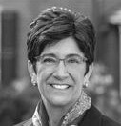
“Shared Leadership” 10:00 - 11:15 am—Workshops
12:45 –1:45 pm—Lunch
1:45 – 3:00 pm—Workshops

Afternoon Workshop Based on Dr. Drummond’s book:
Dynamic Discernment: Reason, Emotion & Power in Change Leadership

April 7, 2024
@ Immanuel UCC, Shillington
2:00—4:00 pm
Register at: https://drdrummond.eventbrite.com Free workshop

Enjoy an afternoon with Rev. Dr. Sarah B. Drummond while she leads a workshop on her book Dynamic Discernment: Reason, Emotion & Power in Change Leadership.
This workshop is designed for both clergy & Lay Leaders to be engaged in practical application for their own settings.

Registration will begin at 1:30

