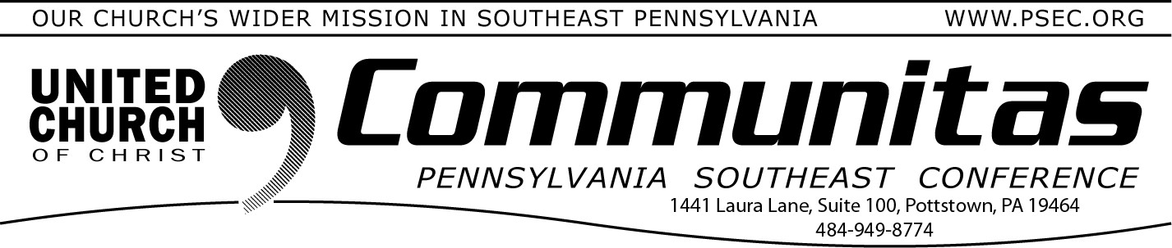
Lay Leadership Convocation 2024

This Year’s Theme: Sharing Leadership

January 28, 2024

Book Study Offered by the
Zachariah Walker Racial Justice Initiative

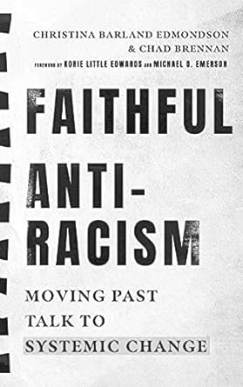
The PSEC Zachariah Walker Racial Justice Initiative is offering a six-week book study on Faithful Antiracism: Moving Past Talk to
Systemic Change, by Christina Barland Edmondson and Chad Brennan. This book speaks directly to Christians who may feel ill-equipped to recognize and respond to racism. The authors use research analysis,
theology, history, and social-political ethics to create interventions that challenge and resist racism in our institutions and everyday lives.
There are two different time slots available for this exciting six-week book study:
Thursdays from 7:00-8:00p, Feb. 1—March 7
(Hosted by Rev. Ann Therese Ortiz and Liz Brunton)

Tuesdays from 2:00-3:00p, Feb. 6—March 12
(Hosted by Rev. Geneva Butz and Rev. Stephen Ohnsman)

To register go to psec.org and click on the Events & News tab.
Then click on February. For the Thursday eve sessions click on Feb. 1st for more information and the registration link. For the Tuesday
afternoon sessions click on Feb. 6th for more information and the registration link.
Keynote speaker: Dr. Sarah B. Drummond, Dean of Andover Newton Seminary at Yale Divinity School, New Haven, CT

April 6, 2024
@ Church of the Good Shepherd, Boyertown 8:30 am—3:00 pm
Register at: https://layconv24.eventbrite.com An occasion for inspiration, education, and community building
9:30 - 9:00 am—Registration and coffee
9:00 - 9:45 am—Keynote Address by Dr. Sarah B. Drummond:
“Shared Leadership” 10:00 - 11:15 am—Workshops
12:45 –1:45 pm—Lunch
1:45 – 3:00 pm—Workshops

Workshops being offered:
“Differ We Must”: Steps to engage congregations in overcoming differences.
The Spiritual Life of the Church Choir Sharing Leadership
The Keystone Conference: what is it and why does that matter to the people in the pews.
Why Telling Our Faith Story Matters
Accompanying Our Aging Selves: Being Present with Older Adults Small Sunday School
Engaging the Fringes of the Church How Does the UCC Work Stewardship & Generosity Impact
Churches Sharing a Pastor: An Ancient Model of Ministry for a Contemporary Church.

