4-PA Conference NOON TIME Lenten Prayer Gatherings

January 21, 2024

4-PA Conference EVENING Lenten Study
The 4 PA UCC Conference Ministers and UCC Staff Members will lead weekly prayer
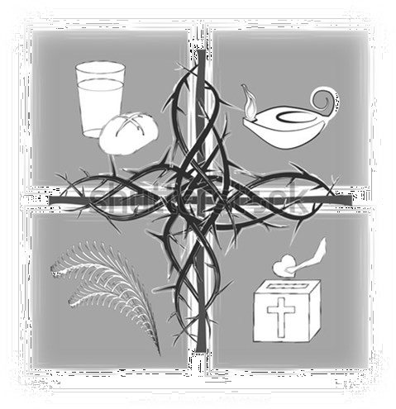
gatherings during Lent on Wednesdays from 12:00-12:30pm. The first prayer time is Wednesday, February 21 and will follow each Wednesday until March 20th.

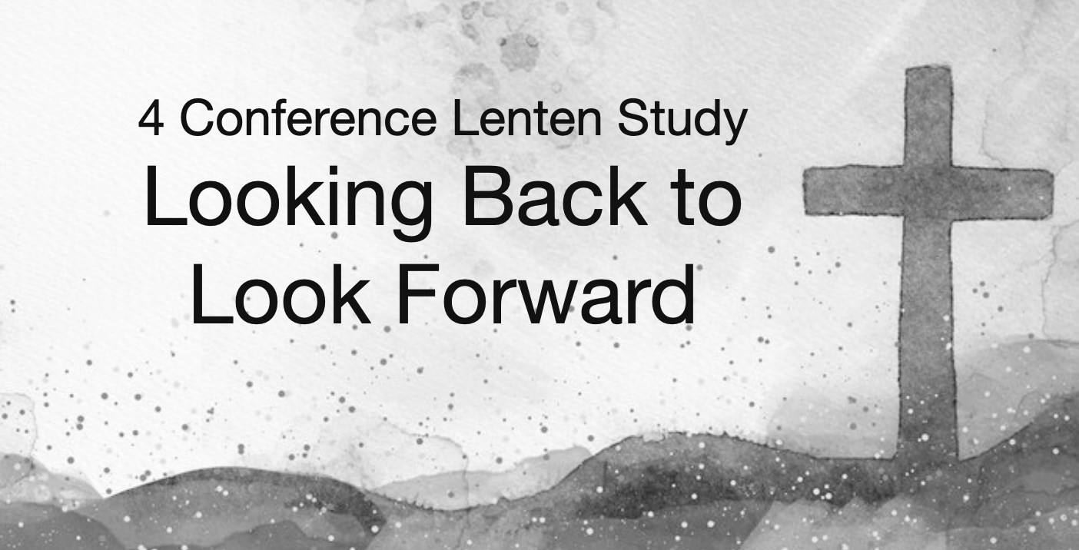
To receive the link go to psec.org and click on the Events & News tab and then the
Calendar. Go to the date of February 21st and click on the Lenten
Prayer Gatherings for more information, or simply use the following link: lentenprayergatherings.eventbrite.com

The Penn Central, Penn Northeast, Penn West and Penn Southeast
Conferences of the United Church of Christ cordially invite you to participate in this virtual Lenten opportunity meeting each Wednesday in Lent at 7:00 pm. This Bible Study explores the foundations of our identity as Christians and members of the UCC as we explore what the future may hold!
Each week is unique so if you cannot attend every date you can still participate in as many as you are able.
If you have any questions, or you would like to participate in this study, please email Patty at pattyr@pnec.org to receive the link.
February 21: Unity and Foundation February 28: United Church of Christ March 6: Lent in Context
March 13: The Priesthood of All Believers March 20: Communion

2nd Annual Lay Leadership Convocation

The Second Annual Lay leadership Convocation of the Pennsylvania Southeast Conference UCC will be held Saturday, April 6, 2024, at the Church of the Good Shepherd, Boyertown.

Keynote speaker will be Dr. Sarah B. Drummond, Dean of Andover Newton Seminary at Yale Divinity School and author of Sharing
Leadership. The convocation will include numerous workshops on topics
of interest to Elders, Deacons, and other church leaders. Registration should open by the end of January.
For now, please save the date!

