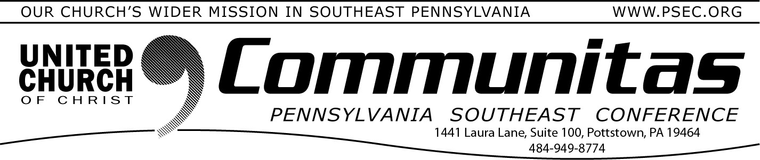
Book Study—The Sunflower: On the Possibilities and Limits of Forgiveness by Simon Wiesenthal

January 14, 2024

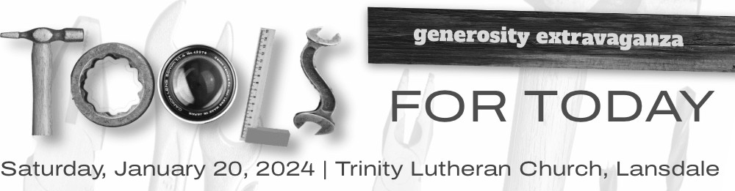

Sponsored by and for the Southeastern and Northeastern Pennsylvania synods and our partners

January 20, 2024
8:30 am to 3:45 pm

Trinity Lutheran Church
1000 W. Main Street, Lansdale, PA 19446
Cost is $40 per person*

Our 2024 Generosity Extravaganza — “Tools for Today” — recognizes that congregations are looking for practical, usable ideas and
programs to help them develop a culture of generosity.

Join us on Saturday, January 20, 2024, at Trinity Lutheran Church in Lansdale. You will learn usable ideas and programs to help develop a culture of generosity in your congregation.
- Keynote speaker – Grace Duddy Pomroy on creating Alternative Funding Methods for congregations.
- Workshop leaders include Doug Powe, Marianne Brock, Philip Krey, Clyde Walter, Andrea Walker, Micah Krey, Tim Brown, and Carolyn Wilt.

For more information and to register go to:
https://ministrylink.org/generosity-extravaganza-2024-tools-for-today/

We also ask you to watch for details on PSEC's Generosity educational opportunities to be offered in 2024!
Requirements: Purchase of the book and pre- registration.
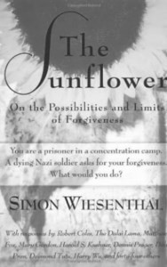
Continuing Education credits are offered for those completing (3.75 hours for attendance across all three meetings)
Laypersons are welcome to join the book study.
Dates: February 13, 20 and 27 (Three Tuesday nights via ZOOM.)
Times: 7:00 – 8:15 pm
Cost: Free

From the book’s description: “While imprisoned in a Nazi concentration camp, Simon Wiesenthal was taken one day from his work detail to the bedside of a dying member of the SS. Haunted by the crimes in which he
had participated, the soldier wanted to confess to – and obtain absolution from – a Jew. Faced with the choice between compassion and justice,
silence and truth, Wiesenthal said nothing. But even years after the war had ended, he wondered: Had he done the right thing? What would you have done in his place?In this important book, fifty-three distinguished men and women respond to Wiesenthal’s questions. They are theologians,
political leaders, writers, jurists, psychiatrists, human rights activists, Holocaust survivors, and victims of attempted genocide in Bosnia, Cambodia, China, and Tibet. Their responses, as varied as their experiences of the world, remind us that Wiesenthal’s questions are not limited to events of the past. Often surprising and always thought-provoking, The Sunflower will challenge you to define your beliefs about justice,
compassion, and human responsibility.”
Led by the Rev. Kevin McLemore, the Associate Conference Minister for Search and Call, this book study for lay and clergy will read The
Sunflower and discuss Wiesenthal’s question of whether he did the right thing by keeping his silence. As Christians, we are commanded by Jesus to forgive “seventy times seventy” but this book explores the nature of
forgiveness itself, and if there are some acts that simply unforgivable for humans to forgive. Join us for a rich discussion over three Tuesday evenings in February.
To register go to psec.org, click on the Events & News tab, then click on the Calendar. Go to the date of February 13 to register.

