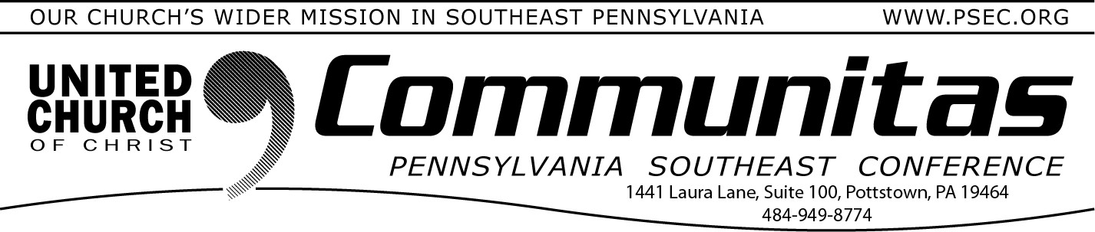
December 31, 2023

“One moment in time allows us to begin again, and again..”
As most of us already know, we experienced another New Year some 4 or so weeks ago on the first Sunday of Advent. Other cultures and countries celebrate a different New Year than ours. I think of these multiple New Years as a way of reminding us that there are multiple
beginning points in our lives, not just one, or two, but many moments when we can get up and get going. Some of those new beginnings are welcomed ones, and others not so much, as life forces them upon us despite our protestations.
The times that have challenged me the most is when I felt like a new beginning wasn’t possible, that there was no way to begin again, to
start over, or to go in another direction. Sometimes the inability to see a possible new beginning, a new start, was something I imposed on
myself, and other times it really did feel as if there were no obvious new doors I could open, or places where I could begin again. I think some of that latter thinking came from the theological tradition I came out,
where the life of faith was traced to one single moment in ones life, and everything came out of that singular moment.
As I’ve grown in my faith, I’m constantly aware that I can begin again, that we can begin again, if we don’t think that beginning again means going backward, but towards something new. In Romans 6:4, Paul
speaks of our baptism as setting us forth onto a new path of life. That
one moment in time allows us to begin again, and again, and again, until God finishes God’s work in us. Every day is a chance to begin again, to
let go of the past, and greet the future, trusting that God is all about
new beginnings.
Happy New Year and Happy New Beginnings!
Kevin
Rev. Kevin McLemore
PSEC Associate Conference Minister for Search & Call

Disaster Response Continues in Berks;
Seeking Paid Help
PSEC is partnering with our ecumenical partners in responding to the summer flooding in Berks County. We had volunteers who supported the Multi Agency Resource Center in July at the Exeter Municipal
Building, helped make call backs to survivors, and/or played a critical role at the mobile outreach center in the Antietam Pool Parking lot in November.
Funding has been found to help with materials for repairs from
Pennsylvania Housing Finance Administration Berks Community Action Program (BCAP). The national setting of the UCC is providing 2 Partners in Service to manage volunteers and construction
supervision. St. Paul's UCC, Amityville, is helping to manage a grant from the national UCC as well.
To help survivors navigate the available resources, high quality disaster case management is necessary. The Lutheran Disaster
Response program of Lutheran Congregational Services has received funding to provide disaster case management services. Therefore, they are seeking to recruit three part time paid contract case
managers. It is projected that these positions will last 6 months to a year. Please read the Position Description and consider applying for one of these positions. Being fluent in both Spanish and English is
helpful. Position description can be found at https://psec.org/wp- content/uploads/2023/12/DCM-Berks-2023-job-description.pdf
If you want to learn more, contact Julia Frank, Director of Community Outreach, Lutheran Congregational Services, 215-430-1299
or jfrank@libertylutheran.org.

PSEC 2023 Giving Cut-Off
Books of the PSEC will close Jan. 22. All OCWM contributions for 2023 must be in our office by that date or they will be counted towards 2024 contributions. Please mail your contributions as soon as possible due to possible mail delays.

