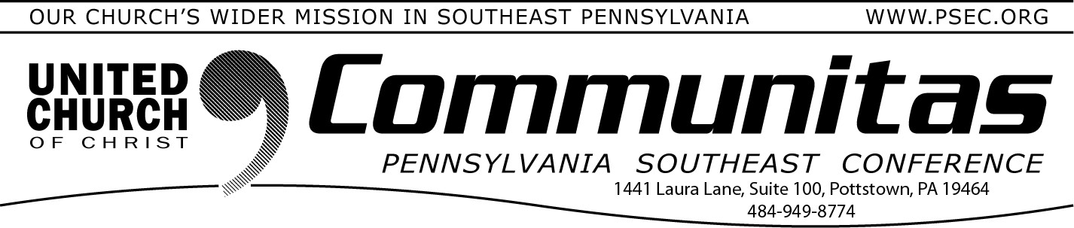

December 17, 2023

Keystone Working Group – Communications Summary of Recent Fall 2023 Meetings
Over the last two months, members of the Keystone Working Group* met to further develop recommendations for the proposed merger of the four area conferences into one Keystone Conference. Meeting October 13 by Zoom, we discussed Associations: how to support and strengthen relationships between congregations, as well as clergy support and
authorization. Task Groups continue to study issues related to: Finance Governance Legal Issues
Approval Process Staffing Needs

During the Fall, each conference held meetings and conversations for people to ask questions, share insights and express hopes for a transformational
kind of ministry. Conference leaders attended many large and small group gatherings to share the Keystone proposal. Great conversations have been had around the relationship and support we want to maintain and build
together. “Together We Are Stronger” has become more than a statement of intention. It describes the real and vibrant faith we embody.

On November 17, the Keystone Working Group celebrated the completion of one year together in study, affirmation, prayer, and discernment. Relying on God’s grace, we heard reports, questions and shared hopes from our gatherings that will inform our future discussions. YOU are making the
difference by your participation in this process of reflection and sharing together.

We continued to define our theology for creating a new conference. While we recognize the strength of our theological traditions, we also respect our diversity, being a “big tent” region with “deep roots.” We invite your prayers for guidance and hope. And we ask that you share information about our proposed merger with your congregations. Relying on the grace of God, we trust God to lead us, believing Together We Are Stronger, The Keystone Conference.

We welcome your observations and questions as you visit the Keystone Conference Project website hosted by the PSEC. https://psec.org/
keystone/ Your questions and comments help us more fully understand how we can help each other work together. You are invited to connect with us by email, at Keystone.Conference.Project@gmail.com. You may also use the postal service and direct mail to the Keystone Working Group through your own area Conference Office.
Remember to Save the Date for the updated joint meeting of all 4 conference areas, June 7-9, 2024 at State College.

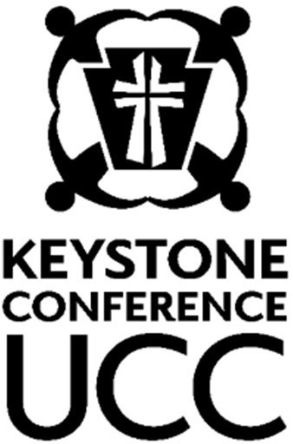
We looked at a possible logo to further unite our proposed merger and the commitment to build relationships which help us make our entire area
stronger. Looking at the progression of our journey, we have chosen to focus on people — figures uniting. These figures of subtle hearts, joining hands in a circle of collaboration and connection, signify the unity this new Keystone Conference embodies. The addition of the cross on the keystone is a nuanced yet powerful touch, symbolizing our interconnected paths and the
meeting point of ideas. The logo and the statement, “Together We Are
Stronger” are not just a mark or slogan; they are symbols of our dedication to unity and the collective journey we embark on as the Keystone
Conference.

Sharing our progress in grace and hope,
KWG Communications Team

Steve Davis St. John’s UCC, Fullerton (PNEC) Heather Kurtz Zion UCC, Arendtsville (PCC) Bob Fogal Zwingli UCC (PSEC)
Deb Long First Trinity UCC, Youngwood (PWC)

*A study, discernment and working group of the 4 PA area UCC
Conferences – Penn West, Penn Central, Penn NE, and Pennsylvania SE

