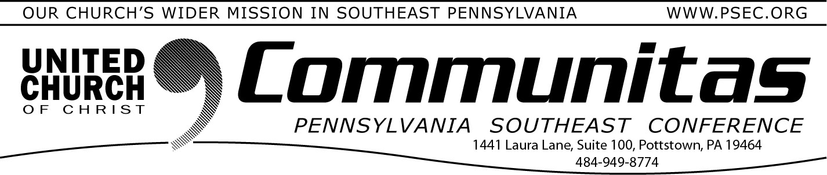
Lay Leadership Support Group
January 7, 2024
Via Zoom!

The PSEC Staff hopes you had a wonderful holiday season and wishes you a very Happy New Year!
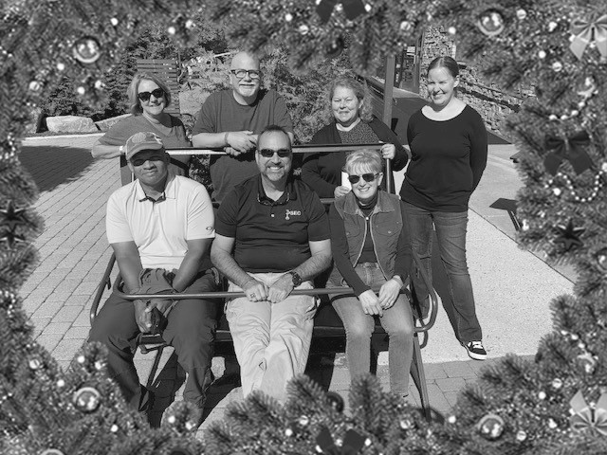
Kim, Kevin, Tammie, Brea Cean, Bill and Sue

PSEC 2023 Giving Cut-Off
Books of the PSEC will close Jan. 22. All OCWM contributions for 2023 must be in our office by that date or they will be counted towards 2024 contributions. Please mail your contributions as soon as possible due to possible mail delays.
A Lay Leadership Support Group exists for Consistory Presidents as well as those serving on Consistory. We gather once a month on Zoom – so please join us at our next meeting January 27th at 10:00 am.

We have found it to be a great place to form new friendships, to gain support, and to be educated on a variety of topics concerning our churches. The discussions are centered around sharing valuable
information about what our churches are doing or maybe could be
doing. This meeting will be online to make ease of attendance for all!

All past attendees will automatically receive an email with the zoom link the Thursday, prior to the meeting. If you are new to the group, please reach out to Susan at the PSEC office at susan@psec.org to be added to the list. New attendees welcome!

Are you singed up for eNews?
The best way to “stay in the know” is to receive the PSEC weekly
eNews. Simply go to psec.org and click on the “Subscribe Today” box in the PSEC Weekly eNews red banner!

List your church events and classifieds!

If you are not already aware, the PSEC website allows our churches to
list their events and post classified ads. Go to psec.org, click on the
Events & News Tab and on the drop-down choose either “Local Church Events” or “Classified Ads”, a sub-tab will open allowing you to
submit your event which will then be shown in eNews as well!

