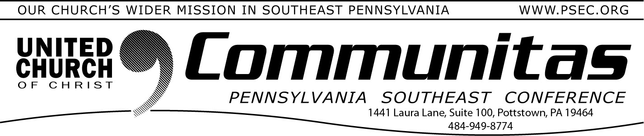
December 10, 2023

Community UCC, Reading is certified 'Accessible 2 All' by UCC

Community UCC, Reading has met the requirements to be certified as an
Accessible 2 All church with the UCCDM (United Church of Christ Disabilities Ministries)! This is an accomplishment we are proud of and wanted to share.
Members of the church became aware of this designation during our search for a settled pastor. The pastor who asked them about the
designation noted that it would help the congregation not only understand the process of acceptance of others but would assist them in becoming an Open and Affirming Congregation. After further
research the church agreed it would be worthwhile and decided to proceed.
The program not only identifies the physical limitations of a church but also identifies the attitudinal changes that must be changed through communication and training sessions. Before beginning the process it’s
important that the leadership understand the program and why you should do it. In Community’s case we did it because it was the right thing to do, not because people would be flooding the doors to join the church. The truth is, if we didn’t know about this program, how does the general public know about it.
After reading through the checklist, most of the things could be checked off right away. There were only a couple of physical barriers that needed to be identified and corrected. The biggest thing was developing the training program for the leadership of the church. We identified the leadership of
the church as being the current consistory members and the ushers who greet those on a Sunday morning each week. Once that was complete the goals were identified for both the short time (1-3 year) and long time (3-5 year) and the application was submitted.
A training program had to be developed for the in-house training of staff, leadership and the congregation. If you are interested, we would be willing to share this training with other churches in our Conference.
- Jeff Kistler, Community UCC Office Manager

One Day Trauma Training Event—via Zoom
Saturday, January 13th

January 13th, 9AM-12PM via ZOOM (AM Session) Trauma 101: An Overview of Trauma-Informed Care
Research shows that 67% of the population has experienced at least one Adverse Childhood Experience. These trauma-based adversities are predictive of a multitude of toxic physical, mental and social outcomes
throughout a person’s lifetime. As a society and as individuals, we need to be better informed and prepared to prevent and address the traumatic
impact of childhood adversities. In this multi-media, interactive workshop, professionals work together to build a powerful image that helps them appreciate the complex nature of trauma and its aftermath.
Overview of Religious Trauma 1What is religious trauma? Definitions. Application of Trauma 101 training to religious trauma. Recognizing types of religious trauma. Sharing/Discussing ways that congregations and leaders can be more trauma-informed and aware of trauma triggers within the context of church.

January 13th –1 PM – 3:30 PM via ZOOM (PM Session) Trauma 102: Basic Skills of Trauma-Informed Care
Building on information provided in Trauma 101, professionals expand
their understanding of trauma and are provided specific skills that enhance abilities to interact in emotionally and relationally healthy ways with people impacted by trauma. As professionals become trauma-aware, they have a responsibility to prevent, avoid and respond to trauma. In this hands-on, interactive workshop professionals are provided opportunities to implement and practice the skills presented.
Overview of Religious Trauma 2Application of Trauma 102 training to religious trauma. Recognizing types of religious trauma, part II. Sharing/ Discussing ways that congregations and leaders can be more trauma- informed and aware of trauma triggers within the context of church.
Creating awareness as to how to response to religious trauma and how to
care for those affected by it.

For more information and to register go to the PSEC website
(psec.org).click the “calendar” under the Events & News tab and go to January 13th. Click on this event.

