Recap of PSEC Fall Meeting

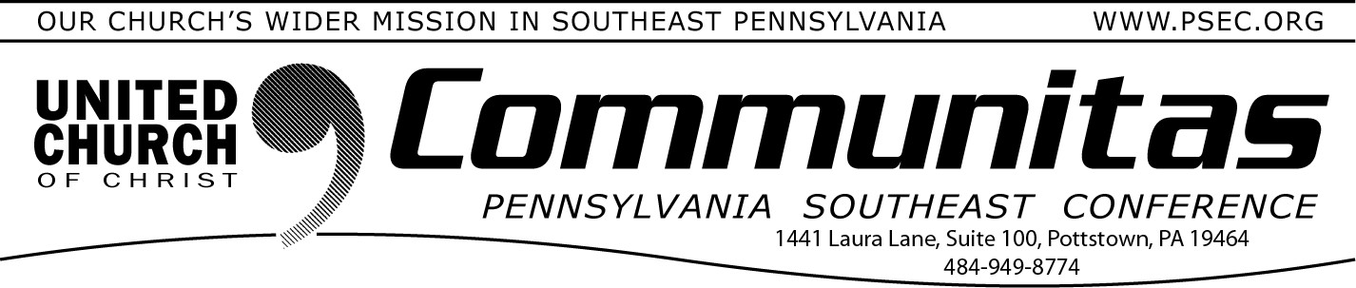

November 26, 2023

Praying “Thank You” Has Power
One of the great blessings of my life is the people who taught me how to pray. When I was a young child, my prayers were all petitions. “God, give me this” and “God, I want that.” My great grandmother noticed this and made it her business to teach me “a more excellent way.” She instructed me to be intentional about always beginning my prayers with thanksgiving. “Lil Mama” (what we called her), told me that God, in some ways, is like anyone else, and who wants to only hear from
someone when they want something?
Saying thank you is powerful and praying thank you has power. Paul suggests the same thing in Philippians 4. Do not be anxious about anything, but in every situation, by prayer and petition, with thanksgiving, present your requests to God.
I firmly believe that thanksgiving helps mitigate the anxiety of petition by reminding us of our blessings, instead of focusing on our areas of
lack. No matter how difficult a season we are experiencing in our lives,
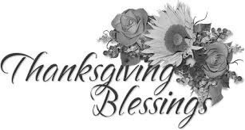
there is a reason to be thankful. Thank you God for the spirit of Thanksgiving!
Rev. Cean James
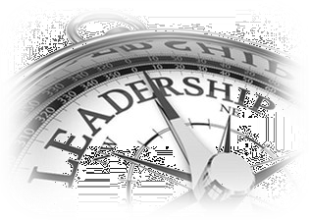
ACM for Congregational Development

Lay Leadership Support Group

The Lay Leadership Support Group, a group for Consistory Presidents as well as those serving on Consistory, will not be gathering during the month of December.

Their next meeting will take place, via zoom on Saturday, January 27th . Watch the January Communitas for more information.
From the Conference Moderator and Conference Minister:
More than a hundred and seventy-seven members and friends met in
person and on-line Sunday for our Fall Conference Meeting at St Paul’s UCC in Douglasville. Their gracious hospitality created a wonderful welcome for our gathering! This was our second attempt at a hybrid Fall meeting, and a great improvement over the first thanks to the work of Revs. Zack Jackson and John Folk.
The meeting opened with worship and music lead by Rev. Steven
Simpson and Martha Sitler based on Joshua 24 with reflections on the
grace of God in whom we share our being and a call to serve. An offering of more than $1100 was dedicated to God and the Justice Witness ministries that happen through our three Conference task forces (Addictions/
Recovery, Racial Justice, Environmental Justice).
We welcomed special guest Mr. Jayaker Daniel Erpula the President of the YMCA of greater Hyderabad who was a gracious host to the members of our Conference on two ecumenical mission trips to the Church of South
India in 2020 and in February of this year. Conference Treasurer Rev. Dr. Bob Fogel shared the challenging news that we are behind in OCWM contributions year-to-date and ahead of Conference expenses. The
Generosity Team celebrated the ways congregations large, small and in-
between contribute to Our Church’s Wider Mission and presented a new OCWM video that explains what those offerings do locally and globally. We passed our 2024 Conference spending plan. Finally, we heard a
presentation of some of the work being done by the Keystone study Group to lead the four Pennsylvania Conferences in conversation about the possibility of becoming one and engaged in meaningful conversation about that.
To all those who traveled from near and far to St Paul’s, Douglasville and those who joined on line, to the Annual Meeting Planning Team, the Conference Consistory, the Conference staff and especially to Rev. Steven Simpson and the brothers, sisters, and siblings of St. Paul’s, and to
everyone who generously supports the work of their local church and the
United Church of Christ, we say thank you and bless you! In the Spirit of the Risen Christ,
Mr. Charles Kuthuru Rev. Bill Worley Conference Moderator Conference Minister

