From the Addiction & Recovery Taskforce: Please help the Addiction and Recovery Clothes Drive

November 19, 2023 The Clothing Drive…. We all do our part and give what we have, but what does it mean? What’s the impact? The clothing drive is in full
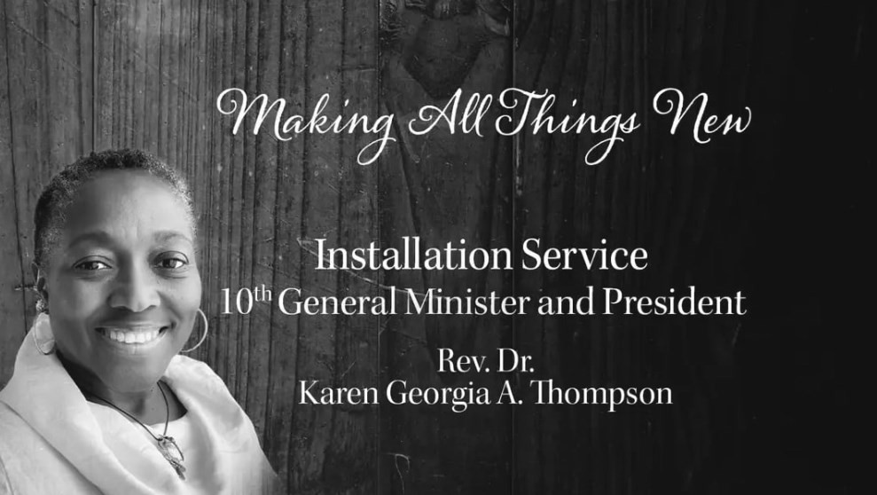
swing. Clothes are coming in and we all feel good about doing the business of God. That is, taking care of God’s people. Collected items will be delivered to ‘Operation in my Backyard’, a grass-roots
organization which provides food & harm reduction services every Tuesday & Thursday to people in the Kensington section of
Philadelphia, specifically at the intersection of Summerset & Ruth.
Let me tell you about who is receiving these blessings you are giving. A young teenager wearing clothes with holes chewed by rodents on the street. An elderly, mentally ill woman who is afraid to look you in the
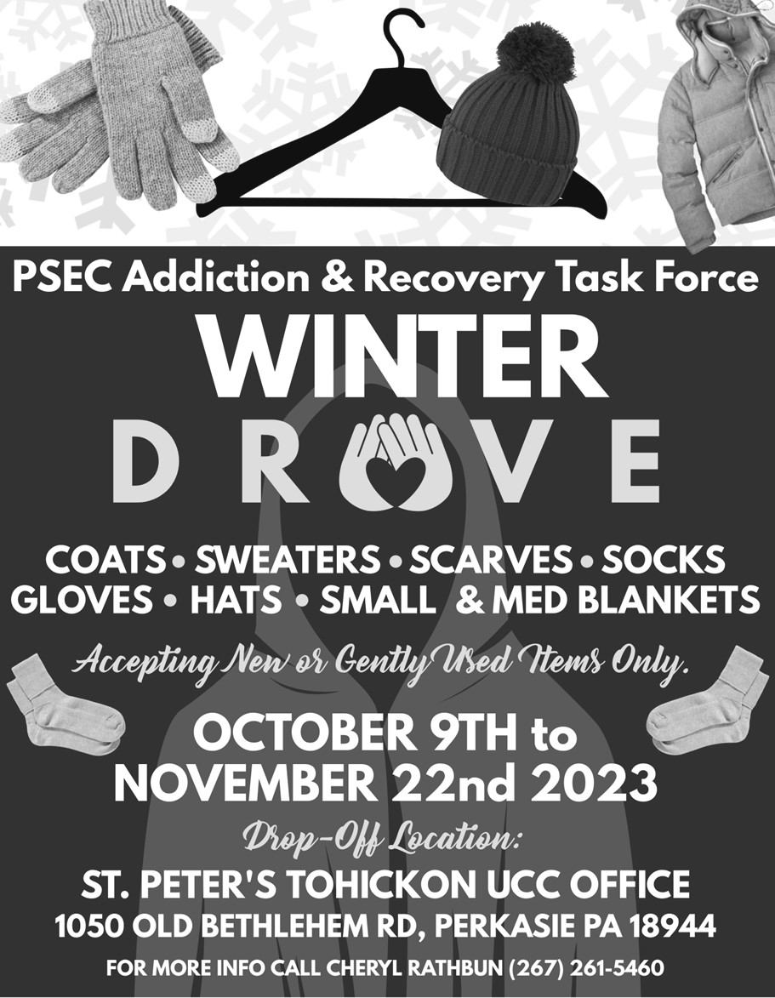
eye, because you will see her pain. A single Mother of four who cannot get a good enough job to buy herself clothes, so she clothes her kids and does without. An
immigrant that

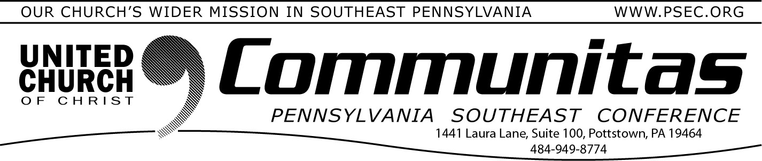
If you missed the Installation Service of our newly installed General Minister and President, Rev. Dr. Karen Georgia Thompson, you may use this link to view it at your leisure:
https://www.ucc.org/gmp-installation/

Tuesday, November 28—Giving Tuesday!
Giving Tuesday restores some balance to the flurry of buying sprees around Black Friday and Cyber Monday. Our Conference is part of this Giving Tuesday movement! Using the "Giving Tuesday" button on the PSEC Donate page (go to psec.org and click the “Donate” button), you can support Our Church's Wider Mission. OCWM supports mission taskforces, disaster response, new ministries, search and call, pastor
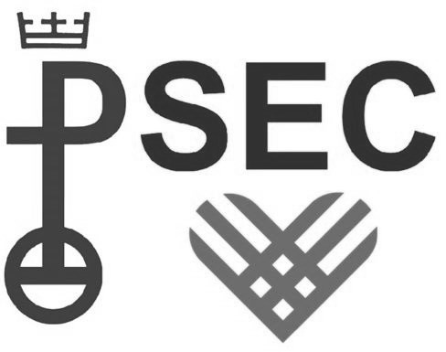
trainings, justice work, and so much more!
We hope you will share this opportunity with your congregation, and support PSEC on Giving Tuesday or donate early! Our goal is to receive 50 gifts; and the first $3,000 will be matched by a lead donor.
doesn’t speak English, so no one will hire
him or help him. Sex workers who struggle to find a warm place to rest. Addicted
persons who do not
know the love of God. This is the short list.
Please give
generously, but also give your prayers and compassion. Thank you. The clothing
drives continues thru THIS WEDNESDAY,
November 22nd.

