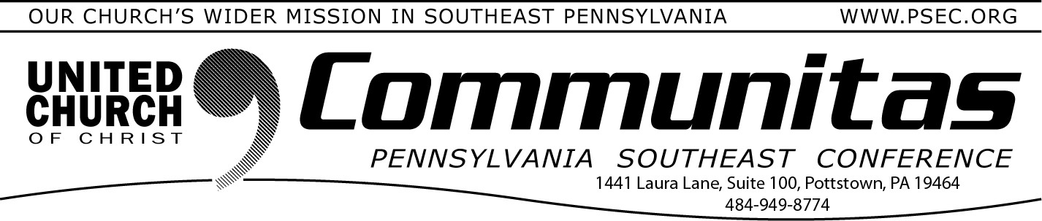
November 12, 2023

Tuesday, November 28 is your chance to join
a global generosity movement – GIVING TUESDAY

Giving Tuesday restores some balance to the
flurry of buying sprees around Black Friday and Cyber Monday. The Tuesday after Thanksgiving is a “giving day” to the causes you and I care about that make for a Jesus inspired just and compassionate world. It’s a day to proclaim that hope is alive and well, despite the many forces of cynicism, division, and destruction.
Our Conference is part of this Giving Tuesday movement!!
Through our network of churches, three working groups (the Addiction and Recovery Task Force
the Environmental Justice Team, and the Zachariah Walker Racial
Justice Initiative) and the countless ways we connect, WE deepen relationships between churches, among clergy, and within communities, to extend the reach of God’s love for the world. This is our life’s mission. And it’s our church’s wider mission.
We hope you will strengthen the mission on Giving Tuesday, as we try to reach our goal of 50 gifts. To inspire our generosity, a lead donor has committed to matching dollar-for-dollar the first $3,000 offered.
TOGETHER we do justice. TOGETHER we love kindness.
TOGETHER we walk humbly with our very giving God!
We hope you will share this opportunity with your congregation, and support PSEC on Giving Tuesday or donate early! Visit the PSEC Donate page by opening psec.org and clicking the Donate button in the top right hand corner then click “Giving Tuesday.

2023 PSEC Fall Meeting
TODAY—Walk-ins Welcome!
Didn’t register, you can still attend in person! (Online registration is closed.)
Hybrid Meeting @ St. Paul’s UCC, Amityville 1979 Weavertown Rd., Douglassville, PA 19518 Registration opens at 2:00 pm
Meeting: 3:00 pm—5:30 pm

Have you ever wanted to join a virtual choir?
Here is your opportunity….
In 2020, during the Covid epidemic, the Penn Central Conference started a Virtual Choir, to provide choral music for remote services. In the years since this choir has continued and has provided wonderful music for ser- vices throughout the years. We would like to invite musi-
cians throughout the state of Pennsylvania to join us for our 2023-2024 season. You won't need to leave home; and you won't need any special equipment.
The choir works remotely and sings 4-5 pieces per year. Setup is simple, and we walk you through the process. Our first piece this year will be a new Christmas Carol by John Rutter. We will be having a series of Zoom orientation sessions the week of Oct. 29-Nov. 4, and guide tracks will be available by Nov. 5, with recordings due back by Nov. 26. Singers in all
voice parts are welcome, as are instrumentalists.
All churches are welcome to use the resulting choir performances,
which are available on the Penn Central Conference's YouTube Channel, and are available for download.
For more information on joining the choir, or using the music, contact Julie Holm, bvfofmusic@gmail.com.

