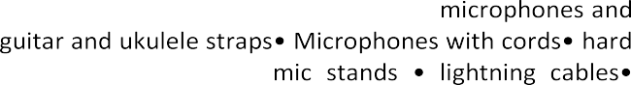
Because many of our churches support Bethany Children’s Home and because Christmas is less than 2 months away, please find below the yearly “Wish List”
Music Education
from Bethany!

Bethany Children's Home Christmas Wish List

We kindly ask that all items are new and unwrapped.

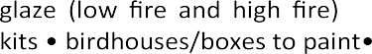
paste • Gesso (White, Black, & Clear) • clear semi-gloss finish spray paint • spray paint, assorted colors • fabric

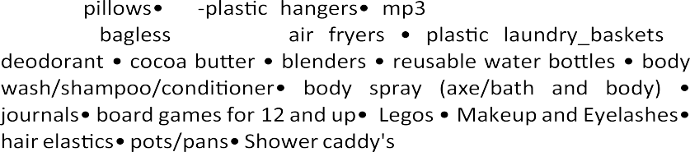
TJ Maxx, Ross, Dick's Sporting Goods, Ulta, Amazon, Barnes and Noble, Lowes, Home Depot, Michaels, Wal­ Mart, Target, McDonald's and Kohls, Boyer's and Redner's markets, Turkey Hill, Giant, Domino's Pizza, Sheetz, Wawa, Foot Locker• itunes • JoAnne Fabrics • Goggleworks • Shutterfly

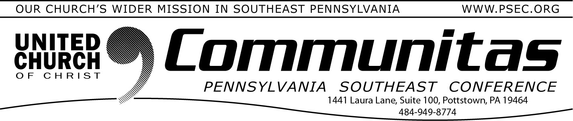
October 29, 2023

2023 PSEC Fall Meeting

Hybrid Meeting @ St. Paul’s UCC, Amityville

1979 Weavertown Rd., Douglassville, PA 19518
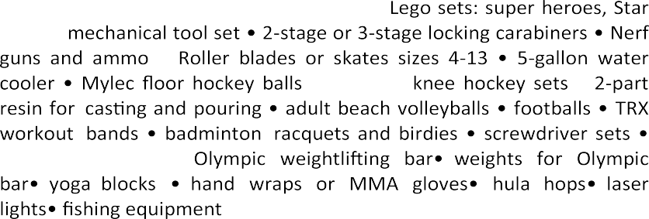
November 12th Registration opens at 2:00 pm Meeting: 3:00 pm—5:30 pm

Register at: psec2023fall.eventbrite.com

