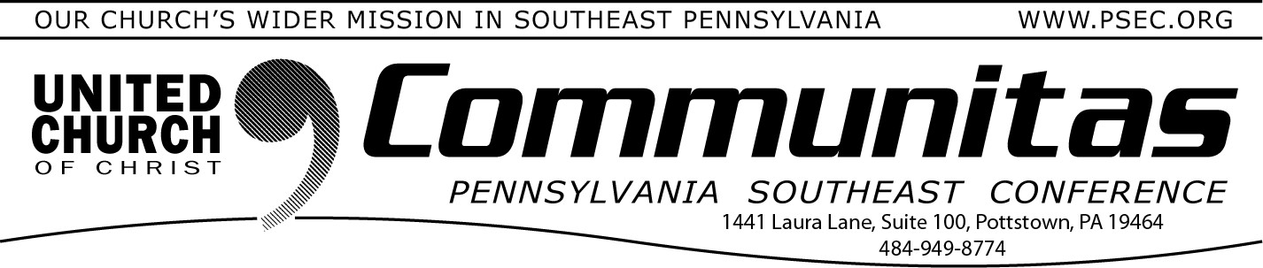
October 22, 2023

You may also bring your donations to the PSEC Fall Meeting November 12th!

Phoebe Berks needs volunteer help from clergy and churches
Prior to COVID, Phoebe Berks was the beneficiary of many community volunteers on Sunday afternoons. Several ministers in the area preached and led worship on occasion, sometimes bringing special music or accompanists with them.
As has been true for most of our congregations, COVID presented difficulties for the Phoebe Berks community to gather in person. Now that our community is approximately 99% vaccinated and our campus is open (with some exceptions to individual rooms or hallways when a resident tests positive for COVID), we would love to have you back! Or, if you’ve never served in this capacity, we’d love to welcome you to join us on a Sunday afternoon.
For the community of Phoebe Berks (Independent Living, Personal Care,
Memory Support, and Skilled Nursing) can worship together, we need
volunteers who are willing to help transport residents with wheelchairs to and from the chapel service. If your congregation, or a particular mission group, or Sunday School class, or youth group would like to help us, please let me know! We will put you and your group in touch with our volunteer coordinator.
We would love to have volunteers who:
Are able to transport residents in wheelchairs to and from services Ministers who can preach and lead worship
Special music groups or an accompanist to lead music for services If you're interested or have any questions, reach out to lknox@phoebe.org.

From the Addiction & Recovery Taskforce: The effects of recovery
When I began recovery, I learned about my behaviors and patterns that shaped the relationships around me. One of the biggest was my Mom. When I was caught in the grips of my addiction, I didn’t see how worried I made her, how many times she tried to help, only to be ignored, all the promises broken, all the late nights, the crying…. but worst of all, it was her heart I broke. I’ll
never forget that.
After some time clean, she saw me change and become that which God had intended; Happy, joyous and free. I still felt the sting of my past misdeeds, but I didn’t have to repeat them.
For all of those that have cared for and loved us, prayed for us – or are still trying to do so – Please don’t give up. There is hope.
- An addict named Cheryl

