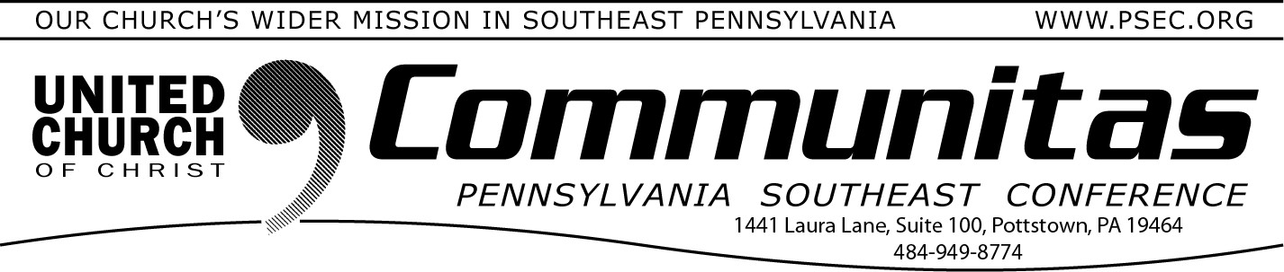
Keystone.Conference.Project@gmail.com. You may also use the postal service
October 15, 2023
and direct mail to the Keystone Working Group through your own area
Conference Office.

Keystone Study Group – Summary of 09-22-2023 Meeting
The 9th meeting of the Keystone Working Group* took place Friday, September 23, 2023. We further developed our plans for presenting recommendations.
We further refined a visual and print presentation which will be shared in many settings across the four conferences. There will be significant opportunity to engage in questions and sharing your hopes for the project. We welcome you to the upcoming conversations over the next several months. We rely on the
grace of God, knowing that Together We Are Stronger, The Keystone Conference.
The Keystone Working Group continues to examine many options for becoming ONE Keystone Conference. We believe the status quo is not an option that
reflects a faithful response to God’s leading. We remain confident that the Spirit of God is leading us into new relationships and models of ministry. We are moved to engage in new possibilities.
We are forming several task groups to study for a new conference: Finance Governance
Legal Issues Approval Process
These task groups will explore ministry connections to mission, program, ad- ministration and more.
“Together We Are Stronger!” reflects the shared commitment of the four conferences to build our ministry areas and the larger community of faith in the United Church of Christ. As we began almost 7 decades ago as a “united and uniting” denomination, we feel the God’s Spirit inviting us to dialogue together. We welcome your sharing as you visit the Keystone Conference Project website hosted by the PSEC. https://psec.org/keystone/ Read about how this project
came about, our study information and summaries following each meeting.
Your questions and comments help us more fully understand how we can help each other work together. You are invited to connect with us by email, at
Save the Date Now for a “Mini Synod” of our gathering of all 4 conference areas, June 6-9, 2024.

Strengthened by our conversations together, we hear God’s still-speaking voice. We trust our leadership as they give guidance to this process of discernment.
Our KWG team holds each other in prayer and partnership, believing that YOU anticipate a faith that is thriving as this project moves forward. We thank you for your support and prayers. The voice of God calls us to trust each other and rely on God’s grace in the full assurance that . . . “Together We Are Stronger! The Keystone Conference.”

Sharing our progress in grace and hope,
KWG Communications Team
Steve Davis St. John’s UCC, Fullerton (PNEC) Heather Kurtz Zion UCC, Arendtsville (PCC) Bob Fogal Zwingli UCC (PSEC)
Deb Long First Trinity UCC, Youngwood (PWC)
DiAnn Baxley (PCC communications substitute addition) David Mears (PWC communications substitute addition)
*A study, discernment and working group of the 4 PA area UCC Conferences –
Penn West, Penn Central, Penn NE, and Pennsylvania SE

Lay Leadership Support Group Join via Zoom on October 21st

A Lay Leadership Support Group exists for Consistory Presidents as well as those serving on
Consistory. We gather once a month on Zoom – so please join us!
We have found it to be a great place to form new friendships, to gain support, and to be educated on a variety of topics concerning our churches. The discussions are centered around sharing valuable information about what our churches are doing or maybe could be doing.
This meeting will be online to make ease of attendance for all!
To register go to psec.org and click on “Calendar” under the News & Events tab and click on October 21st for information and the free
registration link.

