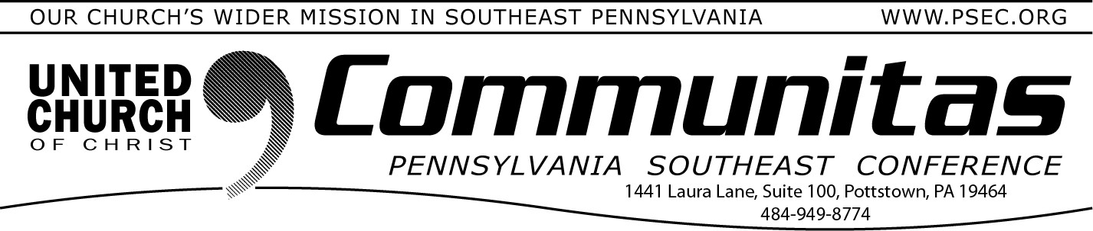
Are you being called to ministry?
The conversation continues.

October 8, 2023

From the Addiction & Recovery Taskforce: Treatment

Faith communities are encouraged to join in the national focus on ad- diction recovery in the month of September. One of the most important realities of this challenge of our time is that many, if not
most, are unable to stop disordered substance use on their own.
Different levels of support are available, many of them in the vicinity of local congregations in our Conference area.
Clinical professionals assess the severity of a substance use disorder in each case based on eleven different criteria, and explore various modalities of support that may fit each person’s needs. These modalities include peer recovery groups – a first and most important
level as evidence has recently shown – professional therapies including residential and non-residential treatment, and various options for medications. While primary care providers may offer a simple screen-
ing referred to by the acronym SBIRT, often the wisest choice for per- sons exploring help is to seek out a subject matter expert – either an addictions therapist, or the intake services of a local treatment
provider.
Pennsylvania’s Department of Human Services offers a list of resources on its website.

Start Planning Now
Mini Synod—June 6-9, 2024

In lieu of the annual PSEC Spring meeting at West Chester University, we will be holding our Spring Meeting within the Mini-Synod with the other PA Conferences in June 2024 at State College, PA.
Start to plan now!
October 25th
7:00 pm via Zoom

Have you ever had the experience of leading worship and felt that you were called to do more of it? Has anyone ever said to you that you should think about being a pastor?

Discussions around these questions and what it means to be “called” were part of a conversation that began this summer. That conversation continues. You need not have attended the first session to join this one.
We will hear more brief stories of people who have answered the call to serve the church in this specific way and reflect on what we’ve discerned since the first session.

Revs. Kevin McLemore and Bill Worley facilitate the conversation.

To register, go to psec.org and click on the Events & News Tab, then click on the calendar and the event on October 25th.

Register to view Installation of the UCC's 10th President: Rev. Dr. Karen Georgia Thompson

Rev. Dr. Karen Georgia A. Thompson will be installed on Friday, Oct. 20 at 5:00p in
Lakewood, Ohio. The service will be
livestreamed. More info and registration are available at ucc.org/gmp-installation.

