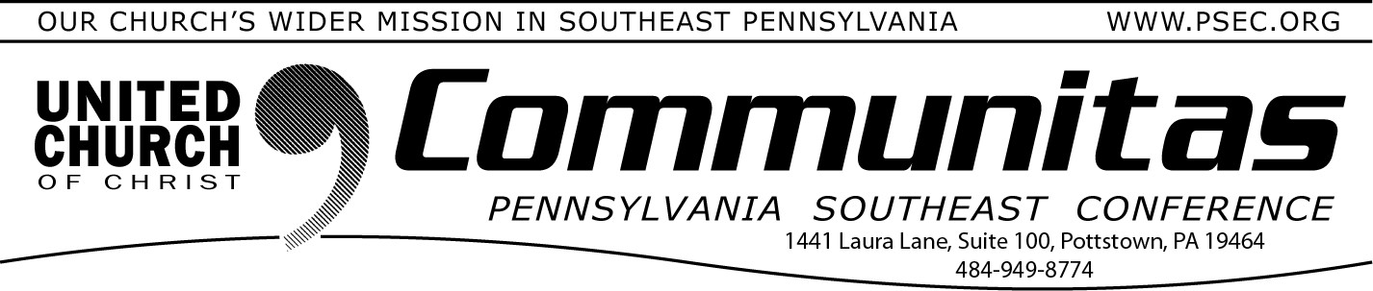
October 1, 2023
To hear more about the Keystone Study Group and the 2023 Fall
Meeting the conference is planning two…

Town Hall Meetings

October 30th @ 7:00 pm—online
Free Registration at: psectownhall1030.eventbrite.com

November 8th @ 2:00 pm—online
Free Registration at: psectownhall1108.eventbrite.com

Come listen, learn and ask questions. Members of the Keystone
Study Group and the PSEC Finance team will be there to assist.

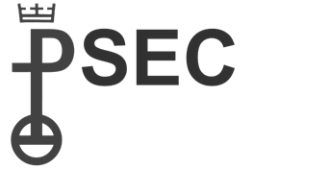
PSEC's Annual Bookkeeper/ Treasurer FREE training
Pennsylvania Southeast Conference of the United Church of Christ
Ms. Caroline Bashore, Conference Secretary

Official Call to the
2023 PSEC Fall Meeting

Hybrid Meeting @ St. Paul’s UCC, Amityville
1979 Weavertown Rd., Douglassville, PA 19518
November 12th Registration opens at 2:00 pm Meeting: 3:00 pm—5:30 pm

The agenda includes:
- OCWM 2023 report and approval of the 2024 Spending Plan
- Report from the Keystone Study Group
Arrive early and visit the tables of some of our committees!

Register at: psec2023fall.eventbrite.com
Saturday, Oct. 14, 9:00-11:00 on Zoom

Do you have questions about 1099 reporting? How about financial reporting to your Board or Consistory? Do you understand housing allowance? Cash basis vs accrual basis?
Do you have Balance Sheet or Income Statement questions?
Email tammie@psec.org your intention to attend and bring your questions!

Free events/workshops brought to you through the generosity of your OCWM giving!

