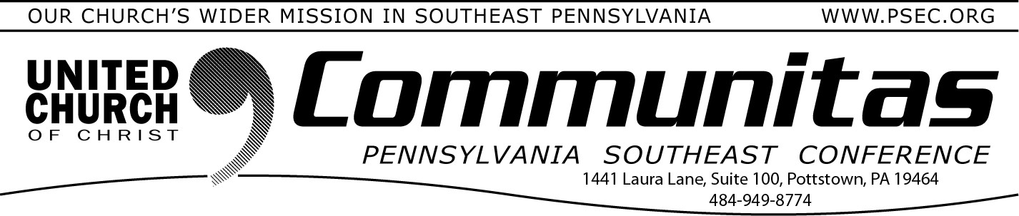
September 24, 2023

Keystone Study Group Summary of 8/25 meeting

The eighth meeting of the Keystone Study Group* took place Friday, August 25, 2023. Relying on the grace of God, we have been busy trying to address next steps in our work outlining how Together We Are
Stronger, The Keystone Conference. The work toward becoming ONE Keystone Conference has caused us to anticipate the many questions which this potential new venture in ministry brings.
We focused on developing the “essential functions” that strengthen effective conference support and service in ministry, as well as authorizing ministry in the great diversity of our settings. In this
gathering, we named desired outcomes for the Keystone Conference,
the “better” and “vibrant” ministry we anticipate. We recognize that God is welcoming us to create something in the power of the Spirit that is
new and challenging.
Each conference area is beginning to plan conversations this Fall to welcome the leaders and congregations to explore our process.
Members of our working group will communicate through many settings: in person, online, in groups large and small, to secure your participation in this vital time of perceiving the “new thing” our still-speaking God is
doing through us all.
Across all 4 conferences, including portions of Maryland and New Jersey, we want to understand how God is speaking to your heart through our

affirmation, “Together We Are Stronger, The Keystone Conference.”
How do you see God creating new vibrancy and hope through this emphasis? We welcome your responses to questions with the invitation for everyone to visit the Keystone Conference Project website
( https://psec.org/keystone/ ) hosted by the PSEC. Read about how this project came about, our study information and summaries following each meeting.
Your questions and comments in the next few months will help us all
grow toward greater understanding and work together. You are invited to email, at Keystone.Conference.Project@gmail.com. You may also use the postal service and direct mail to the Keystone Working Group
through your own area Conference Office.
Each Conference will soon post conversation dates and settings for Fall 2023. Wherever you are, you will have opportunity to engage with us and strengthen the vision of the Church, which God’s Spirit is
developing. In addition, Save the Date Now for a “Mini Synod” gathering all 4 conferences, June 6-9, 2024, in State College.
We hear the voice of God still speaking, calling us to trust each other and rely on the grace of God in the next steps of our journey in the assurance that . . .

“Together We Are Stronger! The Keystone Conference.”
Sharing our progress in grace and hope,

KWG Communications Team
Steve Davis, St. John’s UCC, Fullerton (PNEC) Heather Kurtz, Zion UCC, Arendtsville (PCC) Bob Fogal, Carversville Christian Church (PSEC) Deb Long, First Trinity UCC, Youngwood (PWC)
*A study and discernment group of the 4 PA area UCC Conferences – Penn West, Penn Central, Penn NE, and Pennsylvania SE

Lay Leadership Support Group Not Meeting in September

The Lay Leadership Support Group exists for
Consistory Presidents as well as those serving on Consistory. Although, the groups usually meets monthly , they will not be meeting in September. Their next meeting will take place October 21st.

