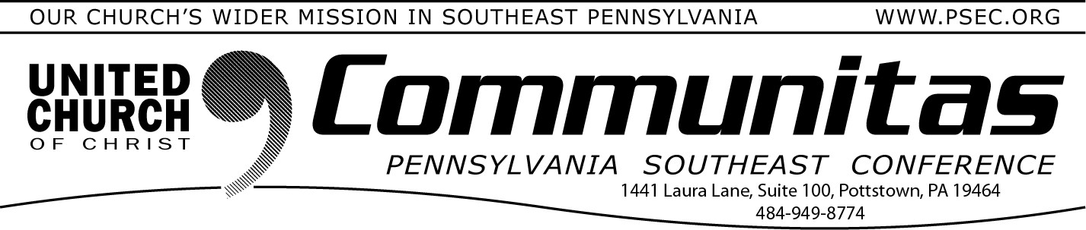
screenings, addiction services, job training and placement, and life skills
education.

September 17, 2023

Old First Reformed UCC

Opening Permanent Housing

Old First House will offer thirty-four permanent supportive homes for formerly homeless individuals. The development is a collaboration
between Community Ventures, Depaul USA, and the Old First Reformed United Church of Christ. Former RHLS Director of Community and
Economic Development, Laura Schwartz, and Staff Attorney Justin Hollinger represented Community Ventures from predevelopment through the project’s financial closing.

The Church, founded in 1727, donated a portion of its property historic Old City campus for the development and partnered with RHLS’s client, Community Ventures, because of their expertise in building low-income housing and working with community groups.

The construction phase is estimated to take about 14 months and once completed, the development will be located in the Old City neighbor- hood in Philadelphia at the corner of 4th and Race Streets. The project represents a unique opportunity to provide safe, stable, and deeply affordable homes in the city’s highest-income zip code, conveniently located close to transportation, healthcare services, and amenities. This new housing development is an extension of the homeless outreach
program which Old First Reformed UCC has been carrying out in the area since 1984.

In addition to the new efficiency apartments, Old First House will
include a community room with a shared kitchen for residents. At the ground level, the building includes commercial space and additional
office space and multipurpose space for the Church. Depaul USA, oper- ating out of two supportive services offices in the building, will provide all supportive services which include case management, healthcare
The development has equity financing from the National Equity Fund, as well as funding from the City of Philadelphia, the Federal Home Loan Bank of Pittsburgh’s Affordable Housing Program, TD Bank, and the
Pennsylvania Housing Finance Agency’s Development Cost Relief
Program which will cover the gap caused by rapidly escalating construc- tion costs.

All 34 units will be covered by a Housing Assistance Payments (HAP) contract with the Philadelphia Housing Authority through the Rental
Assistance Demonstration Project (RAD), making it affordable to tenants at or below 20% of Area Median Income. The mostly vacant parcel
currently contains two rowhouse-type buildings, one of which is listed on the Philadelphia Register of Historic Places and will be moved approximately 48 feet to the south prior to the beginning of
construction; the other building will be demolished. The historic building will be fully incorporated into the new construction and remain the
home of the Church office space.

Laura and Justin provided comprehensive legal services to Community Ventures in support of the project, including project planning and predevelopment, entity formation, negotiation of equity and loan
documents, site acquisition, construction documents, and representation through financial closing.

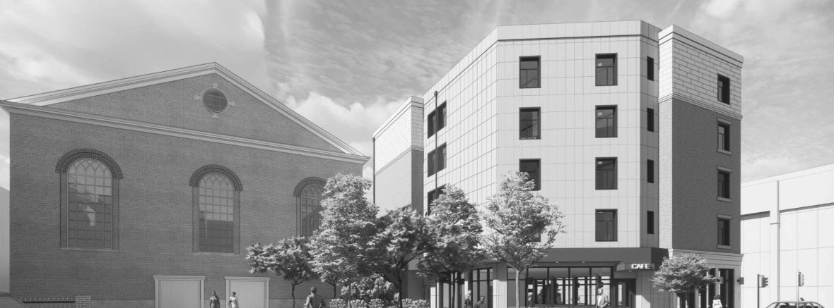
Community Ventures and the Church are planning a groundbreaking and moving ceremony for the project for mid to end of August, where attendees will be able to watch the historic building move on the site.

