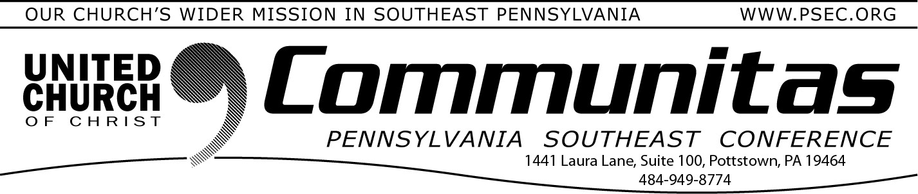

September 10, 2023

The following letter was emailed to all PSEC Pastors and Consistory/Council Presidents on September 1, 2023:
Dear Friend in Christ,
I pray this message finds you in the care and keeping of the Holy Spirit! I write to share important news regarding the merger conversations happening among the four Pennsylvania UCC Conferences.
The PA Conference Ministers had a formative discussion in January 2022
regarding the urgency of issues confronting all settings of the UCC. We’ve heard of the spiritual hunger within our ministers and congregations. We also clearly hear the call to support and develop the local church, especially those in a season of decline. We recognize the urgent yet Spirit-led task of finding and developing leaders that our congregations need. We know the very real
financial challenges impacting the future of our ministries. Finally, we are not the same church we were in 1957. Our contexts of ministry, our issues, our challenges, and our opportunities are different now.
Sharing the burdens and blessings is the only effective way to meet the challenges we face. With this conviction, the “Keystone Study Group,” 25 clergy and lay leaders from all four PA Conferences, was formed. Its mission is to explore the possibility of meeting our shared conference challenges as one body instead of four.
The first monthly Keystone Study Group meeting took place October 15, 2022.
The group has reported its progress after each meeting by digital means (e-news, newsletters, emails, etc.). The reports were also posted to our Keystone website (which you can see here: https://psec.org/keystone/ ).
We have explored why we might move toward merger (Together we are Stronger), and what essential functions of a new Conference would be. We
harvested key lessons from the PSEC and PNEC merger experience, investigated other ministry sharing options, shared dreams and hopes, considered pitfalls and stumbling blocks, and prayed fervently for God’s wisdom and guidance.
Our next steps involve looking at how we would complete such a merger. We gathered the financial leaders to begin assessing the complex financial picture of the four conferences, and this fall we will carefully consider staffing models to fit the functions identified. All that we do is framed by our core theological and ecclesiastical values.
The PSEC Communication team has created a schedule of events and meetings, online and in person, for you to learn about and engage with the work that has been done to date. The schedule can be found at the end of this letter. At those gatherings you will learn more details of the work done to date, meet members of the Keystone Study Group, and consider ways that you may be called to be involved as we move forward.
Please pay particular attention to next June's Keystone Summer Meeting, which will be a joint meeting of delegates and visitors from all four Conferences held June 6-9, 2024 in State College, PA. (Each Conference will also have its own business session to complete their own work that would normally happen in a Spring Meeting.) Please note, there is no intention that State College be a regular meeting site should all four Pennsylvania
conferences choose to merge. This is a “meeting in the middle” of the state and
the Spirit for our initial gathering.
At this celebratory meeting, we will learn about the ministries of all four Pennsylvania Conferences and explore the process of the plan for merger. That process requires Synod and individual Conference support which will be explained in more detail at upcoming association meetings and special
gatherings this fall. Specific details about the Summer 2024 Joint Conference Gathering will be emailed to you before the end of the fall season.
The Keystone Study Group would welcome an opportunity to have a one-on- one conversation with you to answer any of your questions or hear your concerns. You may email the working group directly at
Keystone.Conference.project@gmail.com
Likewise, you are also welcome to call, e-mail or text me directly as your time allows.
God’s Spirit is moving in new ways and leading us forward into a new future! Please pray for this time of discernment and I look forward to seeing you in- person or on-line at an event this fall.
In hope and peace,
Rev. William P. Worley, PSE Conference Minister

Future Town Hall Meetings:
2023: Monday, October 30th @ 7:00 pm via Zoom
Wednesday, November 8th @ 2:00 pm via Zoom
Fall Meeting: Sunday, Nov. 12th @ 3:00 pm @ St. Paul’s UCC,Amityville
2024: Saturday, April 6th at the Lay Leadership Convocation – in person Sunday, April 14th @ 3:00 pm – in person – location TBA, central
to the conference
Monday, May 6th @ 7:00 pm via Zoom
Wednesday, May 15th @ 2:00 pm via Zoom

