Pennsylvania Southeast Conference
of the United Church of Christ

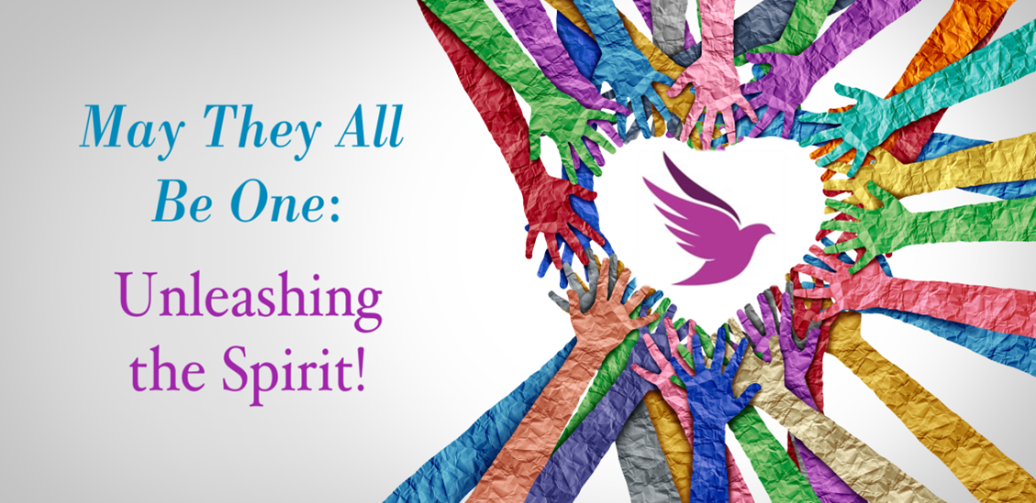

Morning Worship
Saturday, June 3, 2023
2023 Annual Meeting

This is the day that our God has made! Welcome to this time and space! As you arrive for worship and business this morning, we invite you to be in a devotional time either individually or with those at your table.

The theme of this weekend’s meeting is unleashing the Spirit. Last night in worship, we participated in a service renewing our baptismal vows. Whether you were present last night or not, we begin today by remembering Jesus’ baptism and how the Holy Spirit unleashed him to start changing hearts and lives in response to God’s realm. Please read this scripture now, either with those at your table or on your own:

Matthew 3:13-17 (CEB)

¹³ At that time Jesus came from Galilee to the Jordan River so that John would baptize him. ¹⁴ John tried to stop him and said, “I need to be baptized by you, yet you come to me?”

¹⁵ Jesus answered, “Allow me to be baptized now. This is necessary to fulfill all righteousness.”
So John agreed to baptize Jesus. ¹⁶ When Jesus was baptized, he immediately came up out of the water. Heaven was opened to him, and he saw the Spirit of God coming down like a dove and resting on him. ¹⁷ A voice from heaven said, “This is my Son whom I dearly love; I find happiness in him.”

The bowl of water on your table comes from last night’s renewal of baptismal vows. Place your hand in the bowl, take a moment to experience the water, and then with the people at your table or by yourself:

~Take a moment to introduce yourself and say where you are from.
~Briefly tell the story of your baptism—how old were you, where were you baptized, who baptized you, and any details you remember or were told about that moment in your life. (If you have not been baptized, consider what baptism might mean in your life or in the life of someone else.)
~Reflect on how the Holy Spirit has unleashed you to change hearts and lives in response to God’s realm.

As the singing bowl sounds, please conclude your conversations for a time of corporate prayer. When we gather as one body, we will pray:

One: Creator of the world, eternal God,
Many: we have come from many places for a little while.

One: Redeemer of humanity, God-with-us,
Many: we have come with all our differences, seeking common ground.

One: Spirit of unity, go-between God,
Many: we have come on journeys of our own, to a place where journeys meet.

One: Bless our time together this day, God of covenant. May our decisions be wise, blessing the whole of your creation with healing and justice. May our conversations be insightful, learning new perspectives and honoring the voices of all. May our dwelling together be joyful, reflecting the unity you intend among all peoples. May our time be well-spent, forging and renewing relationships, building up your realm on earth, and enlivening us with hope.

One: So here, in this place, let us take time together. For when paths cross and pilgrims gather, there is much to share and celebrate

Many: in your name, Three-in-One God, pattern of community. Amen.

(Adapted from and used by permission from The Iona Abbey Worship Book © The Iona Community, published by Wild Goose Publications, Iona Community, Fourth Floor, Savoy House,140 Sauchiehall St, Glasgow G2 3DH, UK.)

