Pennsylvania Southeast Conference
of the United Church of Christ

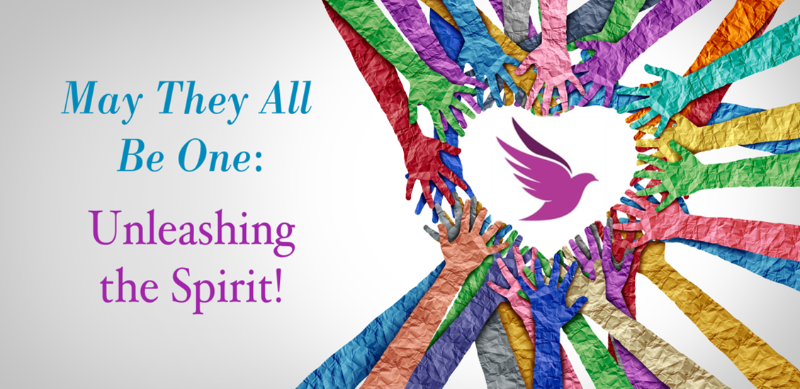

Evening Worship
Friday, June 2, 2023
2023 Annual Meeting

Gathering music & Video “Glacial Lakes” Jill Haley and Dave Cullen
Gathering – Water for each Association is brought forward to create a unified Baptism Font
Opening Song & Scripture
Leader: As I went down to the river to pray…
Sisters: O sisters, let's go down, Let's go down, come on down, O sisters, let's go down, Down in the river to pray.
Covenant-1 Genesis 1: 1-5
In the beginning when God created the heavens and the earth, the earth was a formless void and darkness covered the face of the deep, while a wind from God swept over the face of the waters. Then God said, "Let there be light"; and there was light. And God saw that the light was good; and God separated the light from the darkness. God called the light Day, and the darkness he called Night. And there was evening and there was morning, the first day.
Brothers: O brothers, let's go down, Let's go down, come on down. Come on brothers, let's go down, Down in the river to pray.
North Penn-1 Genesis 1: 6-8
And God said, "Let there be a dome in the midst of the waters, and let it separate the waters from the waters." So God made the dome and separated the waters that were under the dome from the waters that were above the dome. And it was so. God called the dome Sky. And there was evening and there was morning, the second day.
Fathers: O fathers, let's go down, Let's go down, come on down, O fathers, let's go down, Down in the river to pray

Philadelphia-1: Genesis 1: 9-13
And God said, "Let the waters under the sky be gathered together into one place, and let the dry land appear." And it was so. God called the dry land Earth, and the waters that were gathered together he called Seas. And God saw that it was good. Then God said, "Let the earth put forth vegetation: plants yielding seed, and fruit trees of every kind on earth that bear fruit with the seed in it." And it was so. The earth brought forth vegetation: plants yielding seed of every kind, and trees of every kind bearing fruit with the seed in it. And God saw that it was good. And there was evening and there was morning, the third day.
Mothers: O mothers, let's go down, Come on down, don't you wanna go down?, Come on mothers, let's go down, Down in the river to pray.
Schuylkill-1 Genesis 1: 14-19
And God said, "Let there be lights in the dome of the sky to separate the day from the night; and let them be for signs and for seasons and for days and years, and let them be lights in the dome of the sky to give light upon the earth." And it was so. God made the two great lights—the greater light to rule the day and the lesser light to rule the night—and the stars. God set them in the dome of the sky to give light upon the earth, to rule over the day and over the night, and to separate the light from the darkness. And God saw that it was good. And there was evening and there was morning, the fourth day.
Children: O children, let's go down, Come on down, don't you wanna go down? Come on children, let's go down, Down in the river to pray.
Ursinus-1 Genesis 1: 20-23
And God said, "Let the waters bring forth swarms of living creatures, and let birds fly above the earth across the dome of the sky." So God created the great sea monsters and every living creature that moves, of every kind, with which the waters swarm, and every winged bird of every kind. And God saw that it was good. God blessed them, saying, "Be fruitful and multiply and fill the waters in the seas, and let birds multiply on the earth." And there was evening and there was morning, the fifth day.
All: O people, let's go down, Come on down, don't you wanna go down? Come on people, let's go down, Down in the river to pray.
Covenant-2: Call to Worship
Give glory to the Creator and bow before God’s holy splendor!
The voice of the Creator renews and rebirths.
Give glory to the Holy One and bow before God’s holy splendor!
The voice of the Holy One redeems and restores.
Give glory to the Living Water and bow before God’s holy splendor!
The voice of the Living Water refreshes and revives. Glory to God!
North Penn-2 Confession (adapted from the Covenant Renewal Service from John Wesley)
We are those who seek to live as true disciples of Jesus Christ, but sometimes we fall short. Let us now examine ourselves before God, humbly confessing our sins and submitting our hearts so that we do not deceive ourselves or cause ourselves to be separated from God. Let us pray:
Holy God, You have set forth the way of life through Your Son Jesus Christ, whom You love dearly. We confess that we have been slow to learn of Him and have been reluctant to follow Him. You have spoken and called to us but we have not listened. You have revealed Your beauty to us, but we have refused to see. You have stretched out Your hands to us through our friends, but we have passed by them. We have accepted Your gifts and offered little thanks. We are challenged by the gift of Your unchanging love.
We now confess to You our sins.
Forgive us for the poverty of our worship…
for the selfishness of our prayers…
for our inconsistency and unbelief…
for the ways we neglect fellowship and Your grace…
for our hesitation to tell others about Christ….
for the ways we deceive others and ourselves…
Forgive us for when we waste our time on useless endeavors or misuse the gifts You have given us. Forgive us for when we have made excuses for the wrong things we have done and when we have purposefully avoided responsibility.
Forgive us for being unwilling to overcome evil with good; forgive us for not being ready to carry our cross. Forgive us that we have not allowed Your love to work through us to help others or that we have not been present with them in their suffering. Forgive us for those times when, instead of working for unity, we made life harder for others from our lack of forgiveness, inconsiderate judgment, and quick criticism.
Forgive us for when we have not tried to reconcile with others and when we have been slow to seek redemption.
Forgive us also for these sins that we silently lift our personal confessions to you now.
Silent Prayer
Melissa - Words of Assurance and Pardon
Hear the Good News; the God of all mercies is faithful forgive from our sins and restore us to Christ’s image. Praise and glory be to God through Jesus Christ our Lord! Amen. As forgiven and reconciled people, let us offer each other signs of God’s peace.

Musical Offering & Video “Sunrift Gorge” Jill Haley and David Cullen

Philadelphia-2 Scripture
Romans 8: 9-11
You, however, are not in the realm of the flesh but are in the realm of the Spirit, if indeed the Spirit of God lives in you. And if anyone does not have the Spirit of Christ, they do not belong to Christ. But if Christ is in you, then even though your body is subject to death because of sin, the Spirit gives life because of righteousness. And if the Spirit of God who raised Jesus from the dead is living in you, God who raised Christ from the dead will also give life to your mortal bodies because of the Spirit who lives in you.
Please stand as you are able

Hymn of Hope “Take Me to the Water”
1 Take me to the water,
Take me to the water,
Take me to the water to be baptized.
2 None but the righteous,
None but the righteous,
None but the righteous shall see God.
3 I love Jesus,
I love Jesus, I love Jesus.
Yes, I do.
4 In the name of Jesus,
In the name of Jesus,
In the name of Jesus we shall be saved.
5 Glory, hallelujah,
Glory, hallelujah,
Glory, hallelujah, to be baptized.

Schuylkill-2 John 14: 15-20
“If you love me, keep my commands. And I will ask God, and God will give you another advocate to help you and be with you forever— the Spirit of truth. The world cannot accept Her, because it neither sees Her nor knows Her. But you know Her, for She lives with you and will be in you. I will not leave you as orphans; I will come to you. Before long, the world will not see me anymore, but you will see me. Because I live, you also will live. On that day you will realize that I am in God, and you are in me, and I am in you.
Please be seated

Sermon The Rev. Bill Worley
Ursinus-2 - Affirmation of Faith
(Adapted from a reading from the 2nd National Meeting of United Church of Christ Women)
The Body of Christ continues to be renewed and refreshed. As members, we belong to the baptized and covenantal life in Christ. We gather today to affirm our faith and renew our commitments as followers of Jesus.
O God, because You are the source of all life and love and being,
We call You Creator.
Because we know the history of Your presence among Your covenanted people and honor their tradition,
We call you Lord.
Because our Savior, Jesus Christ, Your obedient child, knew You intimately and spoke of You,
We call you Father.
Because You are present in each act of birth; and because You shelter, nurture and care for us,
We call you Mother.
Because You hold us up and give us strength and courage when we are weak and in need,
We call You Sustainer.
Because we have known You in our pain and suffering,
We call you Comforter.
Because beyond pain lies Your promise of all things made new,
We call you Hope.
Because You are the means of liberation and the way to freedom,
We call you Deliverer.
Because You have chosen to come among us and share our common lot, making the hard choices, suffering and dying; because You rose victorious, bringing new life,
We call you Redeemer.
Confident that You will hear, we call upon You with all the names that make You real to us,
the names which create an image in our minds and hearts, an image which our souls can understand and touch. and yet we know that You are more than all of these.
Blessing and power, glory and honor be to You, our God, Amen.
Do you believe in the One of Many Names, God, Jesus Christ, and Holy Spirit?
We believe in the God of Many Names.
Do you reject the powers of oppression in this world, the systems that marginalize and degrade human beings and communities created by God, and the norms of the world at odds with the way of God’s desired community?
We do, with the help of God.
Do you embrace grace as God’s gift, to be freely given and freely received?
We do, with the help of God.
Do you recommit to the covenantal and baptized life, the cost and joy of discipleship, and the community of belonging as a member of the Body of Christ?
We do, with the help of God.
As the waters placed into this vessel came from the four United Church of Christ conferences, so these combined waters, blessed by the Holy Spirit, will be shared amongst us. The water of Life will go through all areas of our worship space and be used for our baptismal reaffirmation.
Our unified and blessed water will be sprinkled by representatives of each Association.

Hymn of Sending “Wade in the Water”

Refrain: Wade in the water,
wade in the water,
children, wade in the water.
God’s gonna trouble the water.
1. See that host all dressed in white,
God’s gonna trouble the water.
The leader looks like the Israelite.
God’s gonna trouble the water. [Refrain]

2. See that band all dressed in red,
God’s gonna trouble the water.
Looks like the band that Moses led.
God’s gonna trouble the water. [Refrain]
3. If you don’t believe I’ve been redeemed,
God’s gonna trouble the water.
Just follow me down to Jordan’s stream.
God’s gonna trouble the water. [Refrain]
4. I went down to the river, Lord.
God’s gonna trouble the water.
Went down to the river to sit and pray.
God’s gonna trouble the water. [Refrain]
Bill - Benediction
Go in hope, that the world will hear the Voice of God and know the Love of God.
Go in joy, for the transforming work of the Spirit has made us new.
Go in peace, and share the good news of Jesus Christ
We are baptized into the world that God has made.
Thanks be to God.
Amen.
+ Parts of this worship have been adapted from “Worship Ways” ucc.org
Songs covered by One License # 708988 or are public domain.
Many thanks to Jill Haley and David Cullen for sharing their musical talents with us tonight.

