Pennsylvania Southeast Conference
of the United Church of Christ

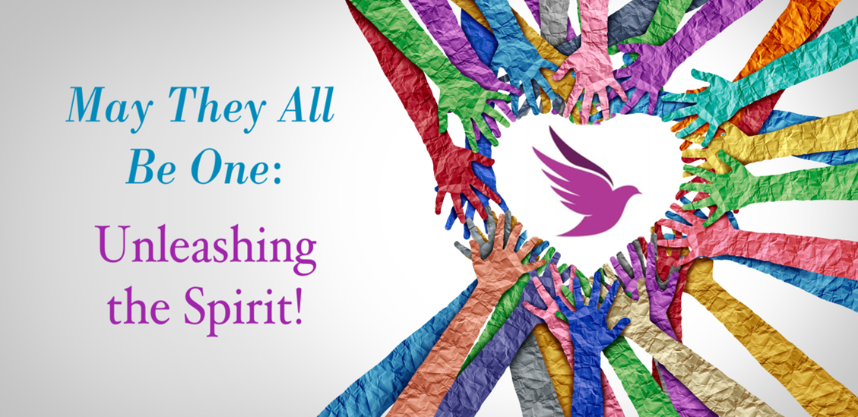

Opening Worship
Friday, June 2, 2023
2023 Annual Meeting

We Gather (voices from each of our five associations)

Ursinus: We come to this space with all of our joys and all of our concerns.
Schuylkill: We come to this space from lives which are busy, which are chaotic, which are often filled with uncertainty.
Philadelphia: We come to this space seeking peace, seeking community, seeking time to pause and be filled with the Spirit’s tender presence.
Many: We come together as sisters, as brothers, as siblings in Christ wandering through the wilderness of life, seeking a drink of living water to sustain our spirits.
North Penn: We gather with all of our fragilities and all of our fault lines.
Covenant: We gather with abundant blessings and glorious gifts.
Ursinus: We gather with hopes, with dreams, with visions for a new way forward.
Many: We gather to release what we can no longer carry as we receive the Spirit’s wonder and wisdom to guide us into whatever comes next.
Schuylkill: Let us listen to each other.
Philadelphia: Let us learn from each other.
North Penn: Let us laugh with each other.
Covenant: Let us love each other.
Many: Let us put aside preconceived notions of what this time of gathering should be and allow the Spirit to show us a new way to be God’s church for the seasons to come.

Moment of Quiet Stillness and Deep Breathing

We Proclaim

Gospel of John 4:7-15 (Common English Bible)

Leader: A Samaritan woman came to the well to draw water. Jesus said to her, “Give me some water to drink.” His disciples had gone into the city to buy him some food.

The Samaritan woman asked, “Why do you, a Jewish man, ask for something to drink from me, a Samaritan woman?” (Jews and Samaritans didn’t associate with each other.)

Jesus responded, “If you recognized God’s gift and who is saying to you, ‘Give me some water to drink,’ you would be asking him and he would give you living water.”

The woman said to him, “Sir, you don’t have a bucket and the well is deep. Where would you get this living water? You aren’t greater than our father Jacob, are you? He gave this well to us, and he drank from it himself, as did his sons and his livestock.”

Jesus answered, “Everyone who drinks this water will be thirsty again, but whoever drinks from the water that I will give will never be thirsty again. The water that I give will become in those who drink it a spring of water that bubbles up into eternal life.”

The woman said to him, “Sir, give me this water, so that I will never be thirsty and will never need to come here to draw water!”

We Sing

God Is Here! As We Your People Meet (NCH #70)

We Pray

Leader: Sacred and Divine Presence, you call us together as your children, as your people, as your disciples. Quiet our minds. Still the chatter within us so we might explore the new possibilities unfolding before us. Lead us from our wilderness wanderings to community, to unity, to sharing of ideas, of resources, of wisdom, of wonder. As we drink of the living water you continually offer, may our spirits be renewed, may our bodies be refreshed, may our doubts be released, may our faith communities be resurrected by the One who is Teacher, who is Savior, who is Grace, who is Love, who is the Christ.
Many: Halleluiah and Amen.

Music covered by One License # 708988

